**Lab 1 Assignment: Using REST (Node.js) and Angular JS**

CPME273: Enterprise Distributed Systems

Sneha Jain (010694697)

San Jose State University, Fall 2015

**Introduction**

The following report contains two applications which demonstrate REST services using Node.js (Express) and Angular JS.

1. Calculator Client-Server implements Stateless Web Services

Calculator performs basic add, subtract, multiply and divide operations using two or more operands, and also takes care of exception handling

1. Facebook application prototype implements RESTful Services

The application is a social networking platform where users share news about themselves (what’s on their mind). Additionally, he also maintains a list of friends whose activities he wants to view, creates groups of users, he also maintains a profile mentioning about himself and his interests.

**System Design:**

Both the applications were developed using the following technologies:

* Server: Node.js server ([Express@3.12.0)](mailto:Express@3.12.0))
* Model: Javascript
* Views: EJS, AngularJS and Bootstrap
* Controller: Node.js
* Database: MySql

**Results:**

1. **Calculator: Server1/Client1**

Testing Calculator client: Performing basic operations

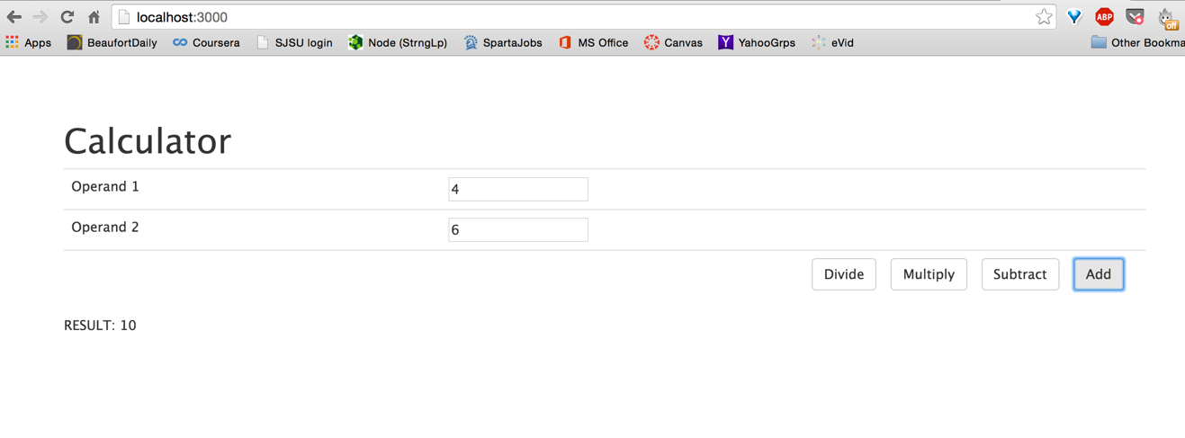

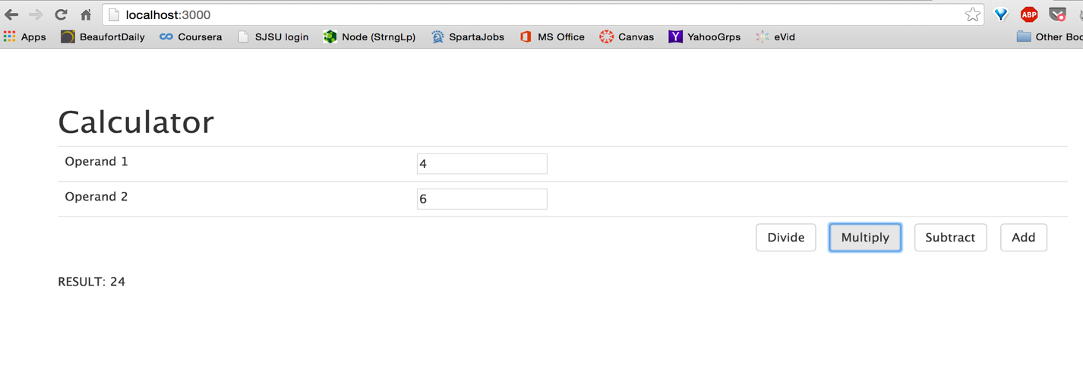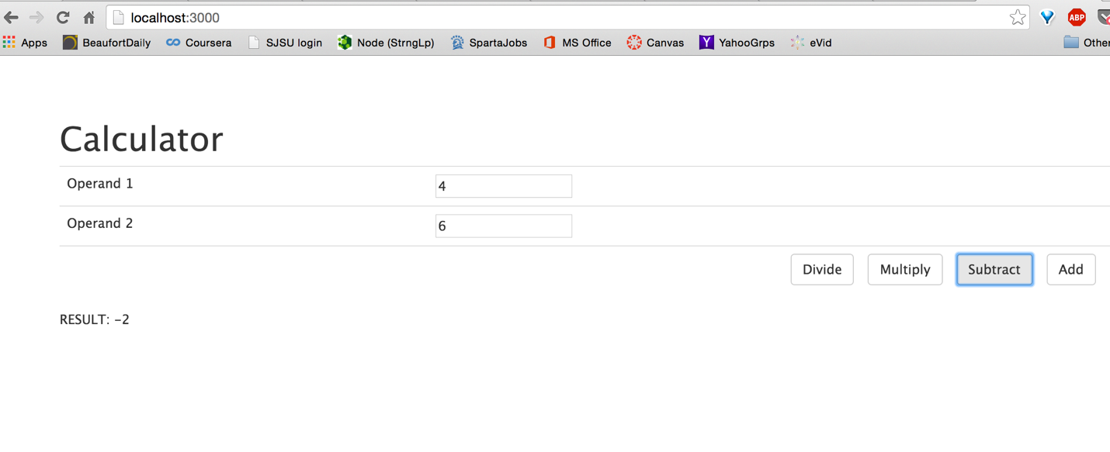

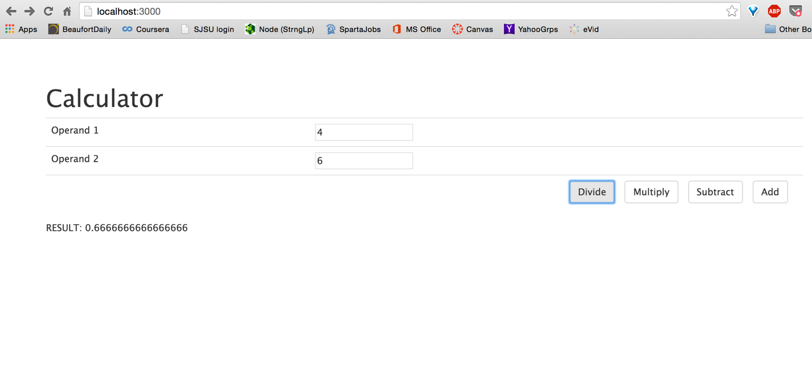

Testing for invalid operands (non-numeric operands)

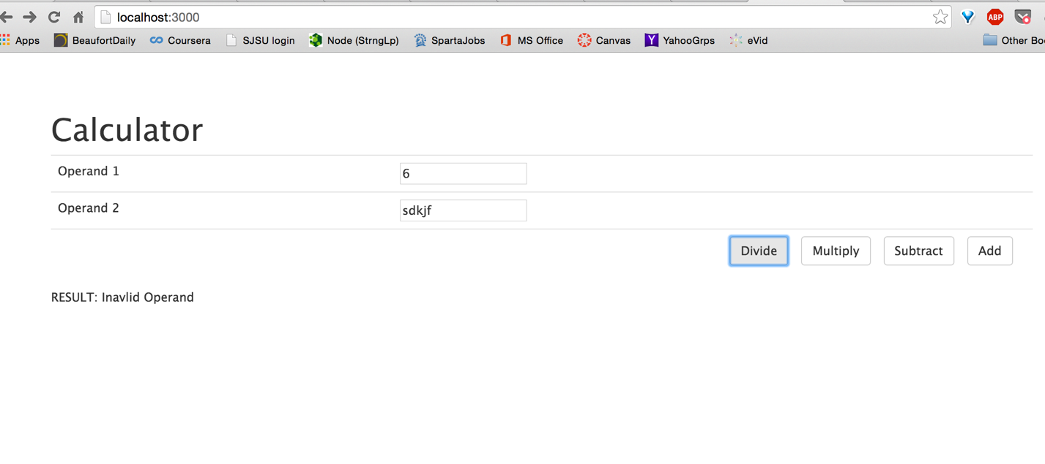

Testing for missing operands

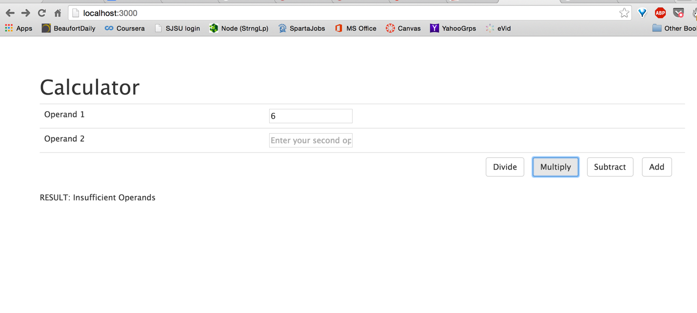

Testing for divide-by-zero error

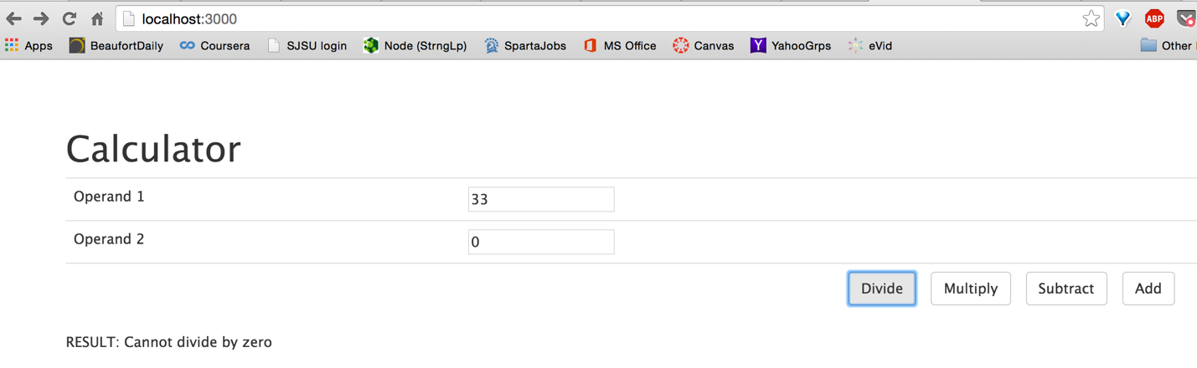

1. **Facebook application: Server2/Client2**

Functionalities added:

* User
  + Login Page

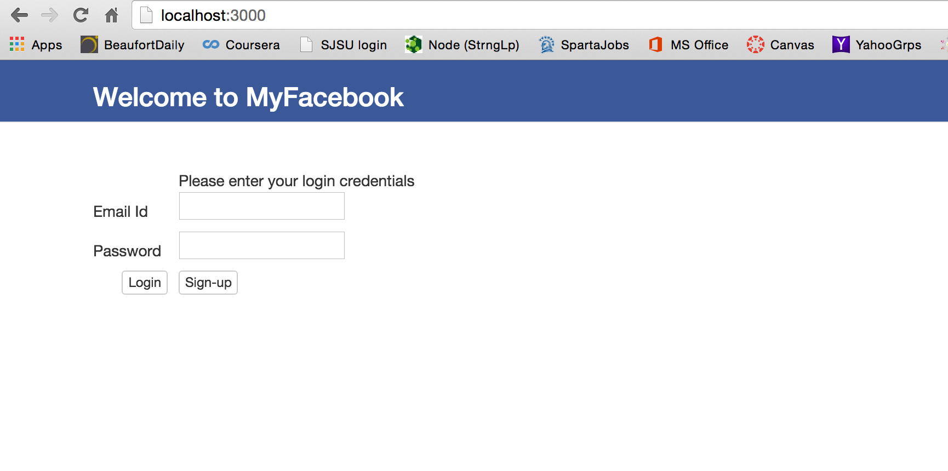

(On successful login, will redirect you to the user profile page/homepage)

* + Signup page:

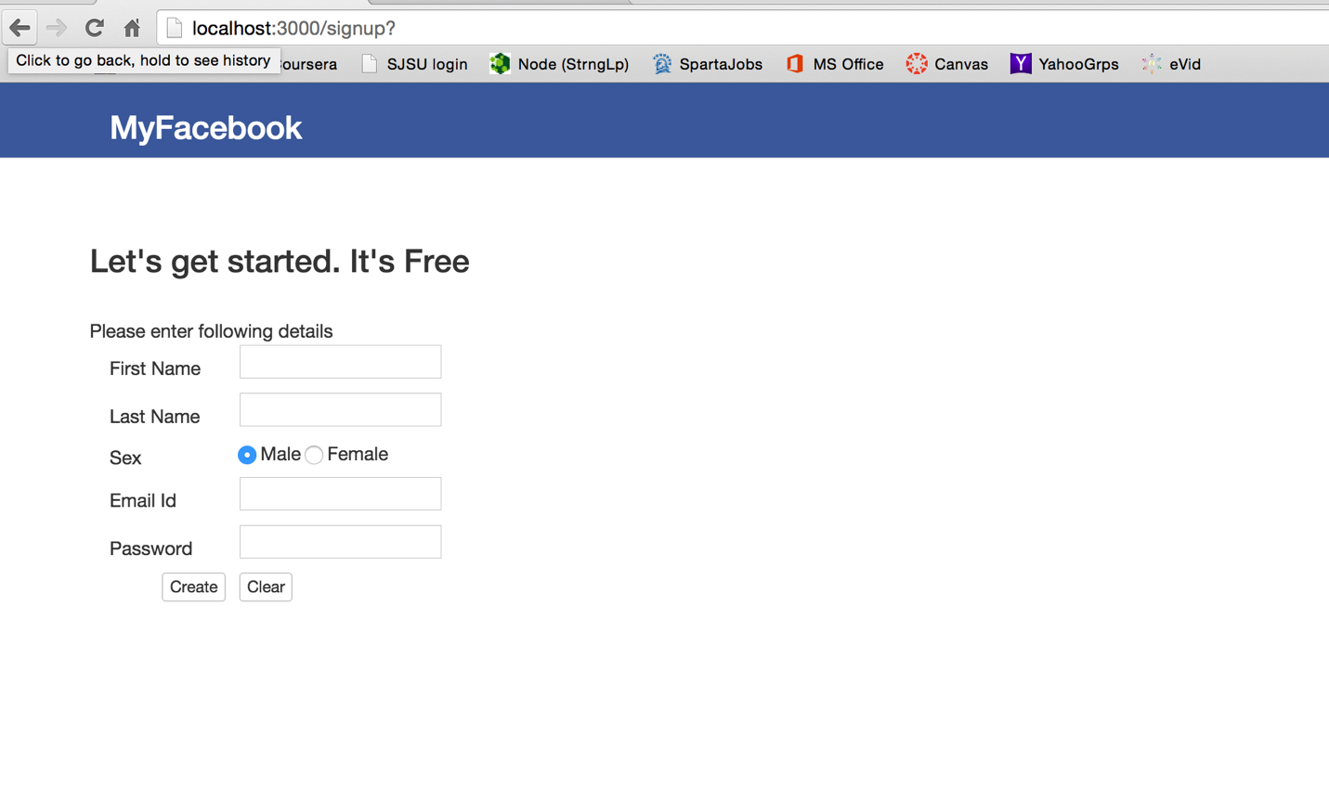

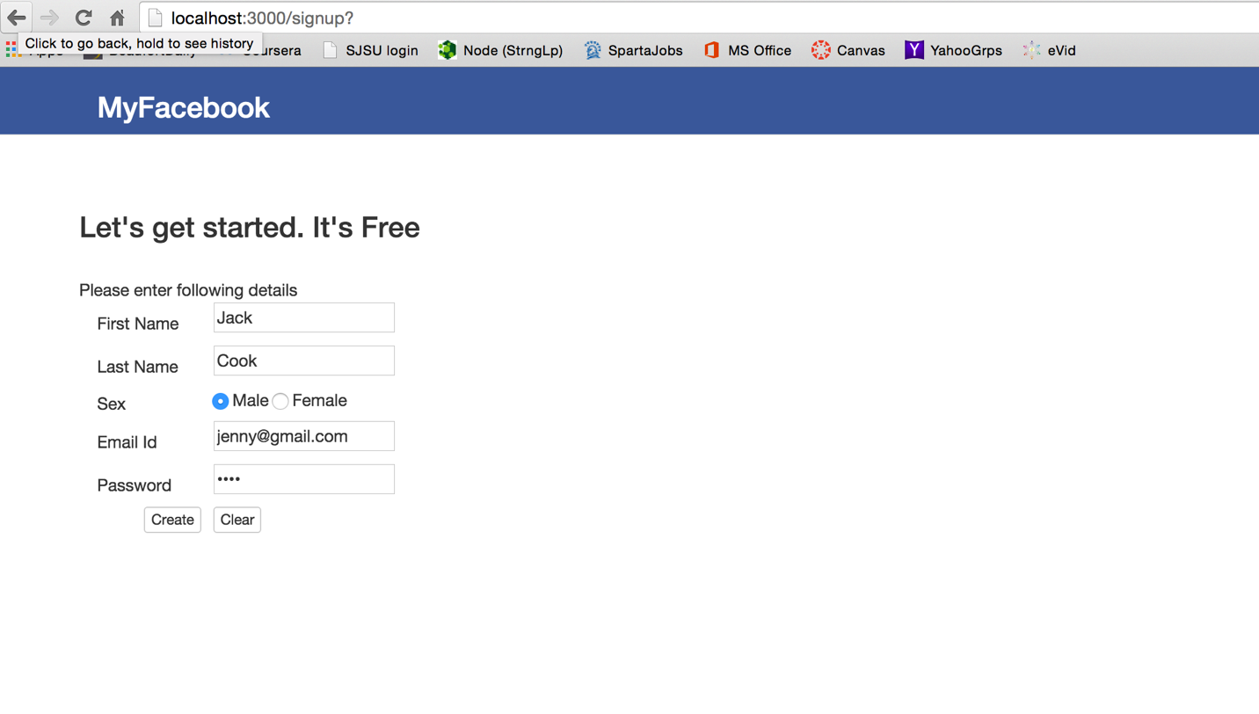

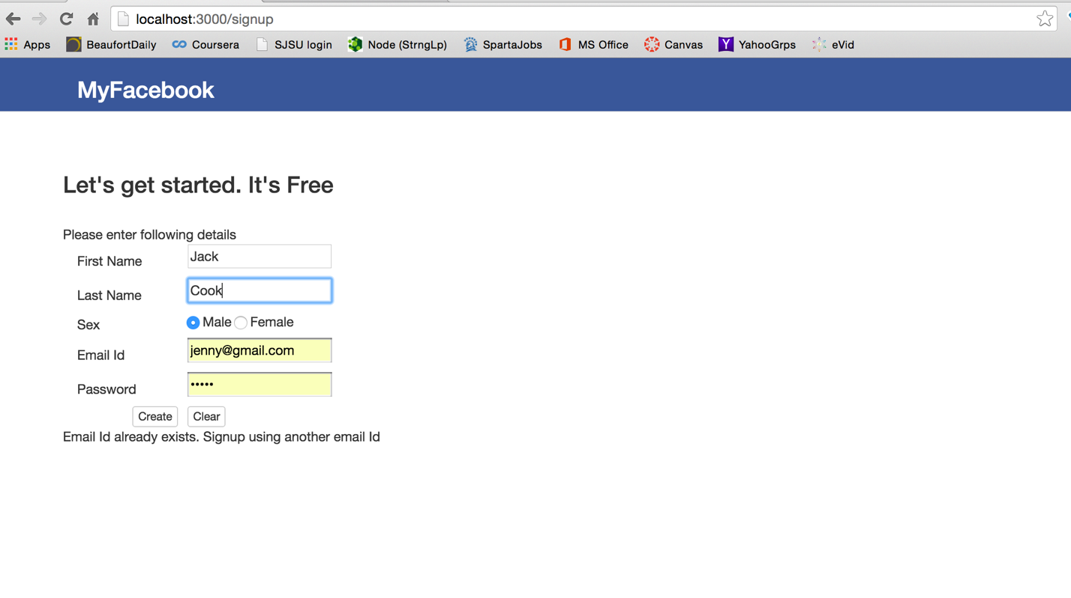

Check for existing email Id will be done to maintain unique signup ids

All fields in signup page are required

* + Incorrect credentials: (Warning message is displayed on incorrect credentials)

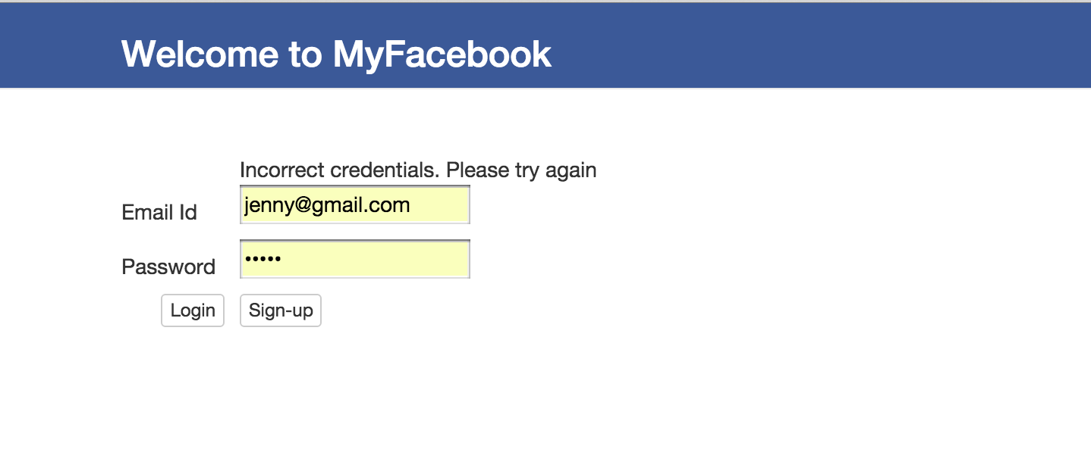

* + Logout: (Users can logout using the option in the caret icon on the right-most corner of the navigation bar)

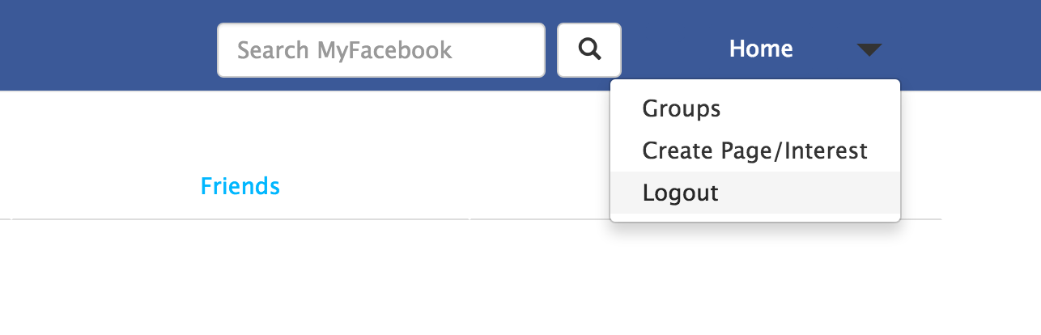

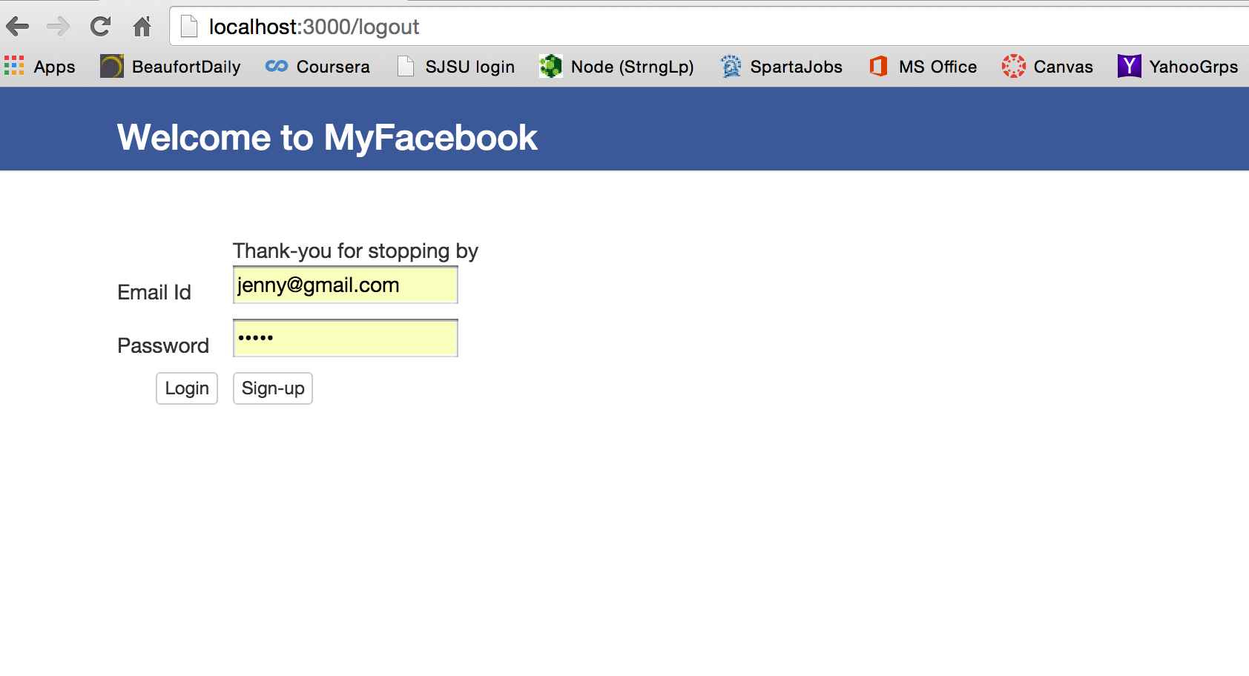

* + Password storing: Password are hashed before storing them into the database for security purpose. Hashing is done using SHA512 hash function, using user email id as a salt to ensure distinct hash for users with same passwords.
* User Profile: User homepage containing tabs for the following sections:
  + **Timeline (Posts)**:
    - View his own posts: User can view his own posts (timeline/wall)

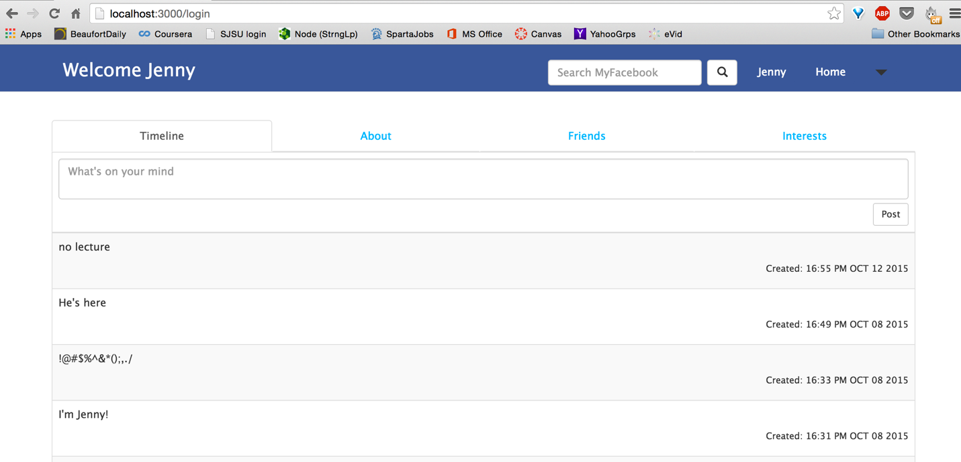

* + - Create a new post: User can create a new post (post on his wall). The post gets reflected in the user timeline on successful creation. Posts can be multi-line input and also all special characters included single inverted comma

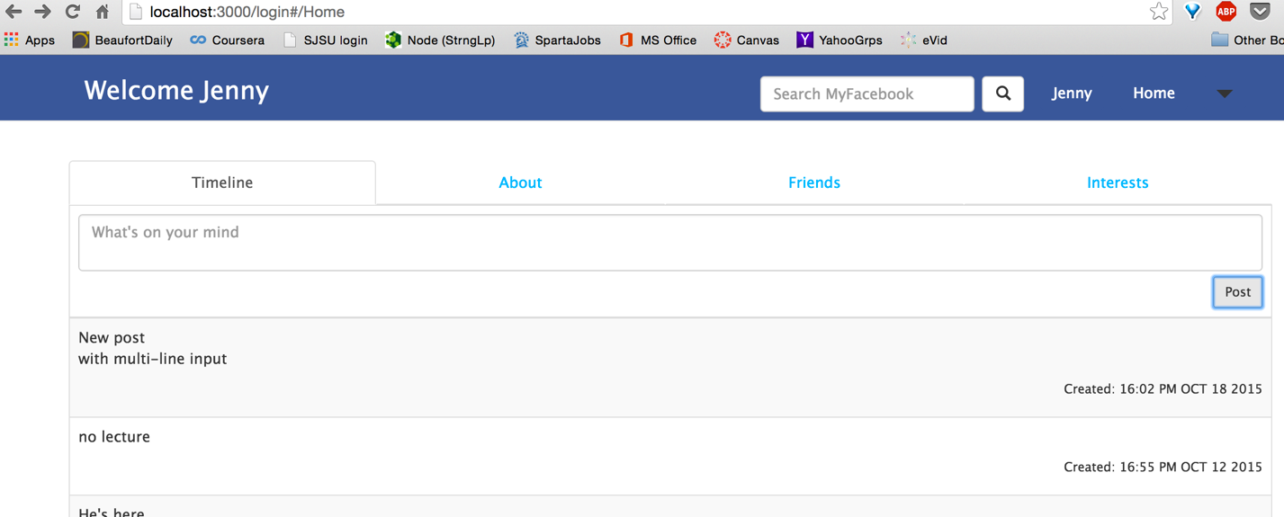

* + **Profile**:
    - View his profile

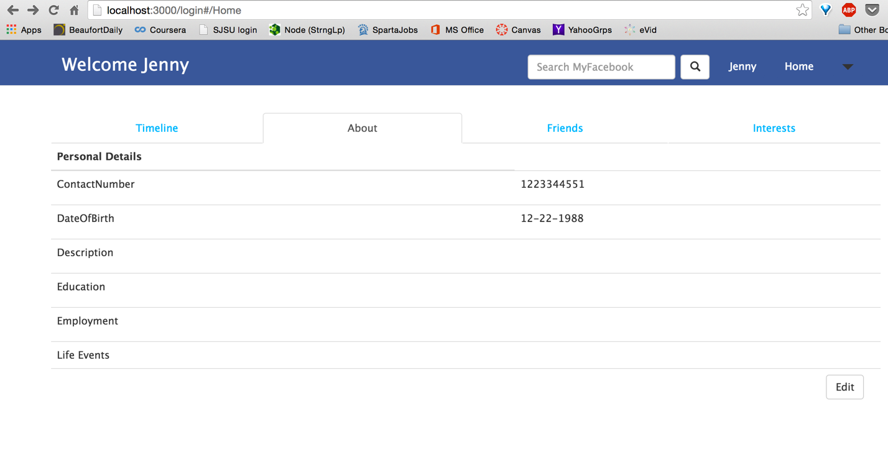

* + - Edit his profile

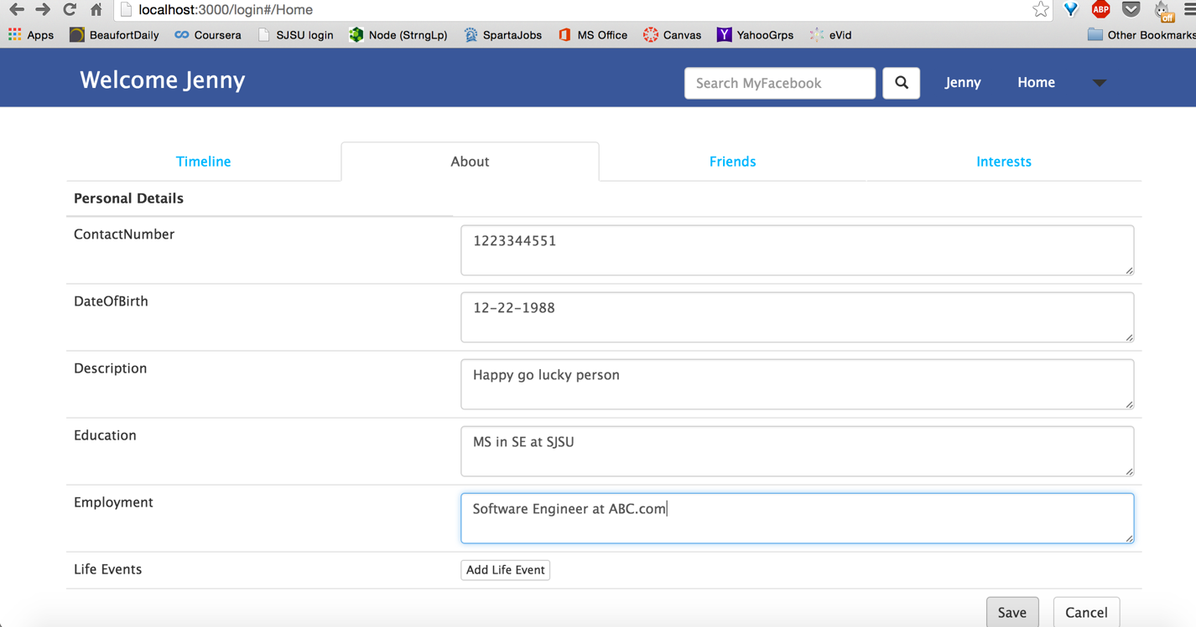

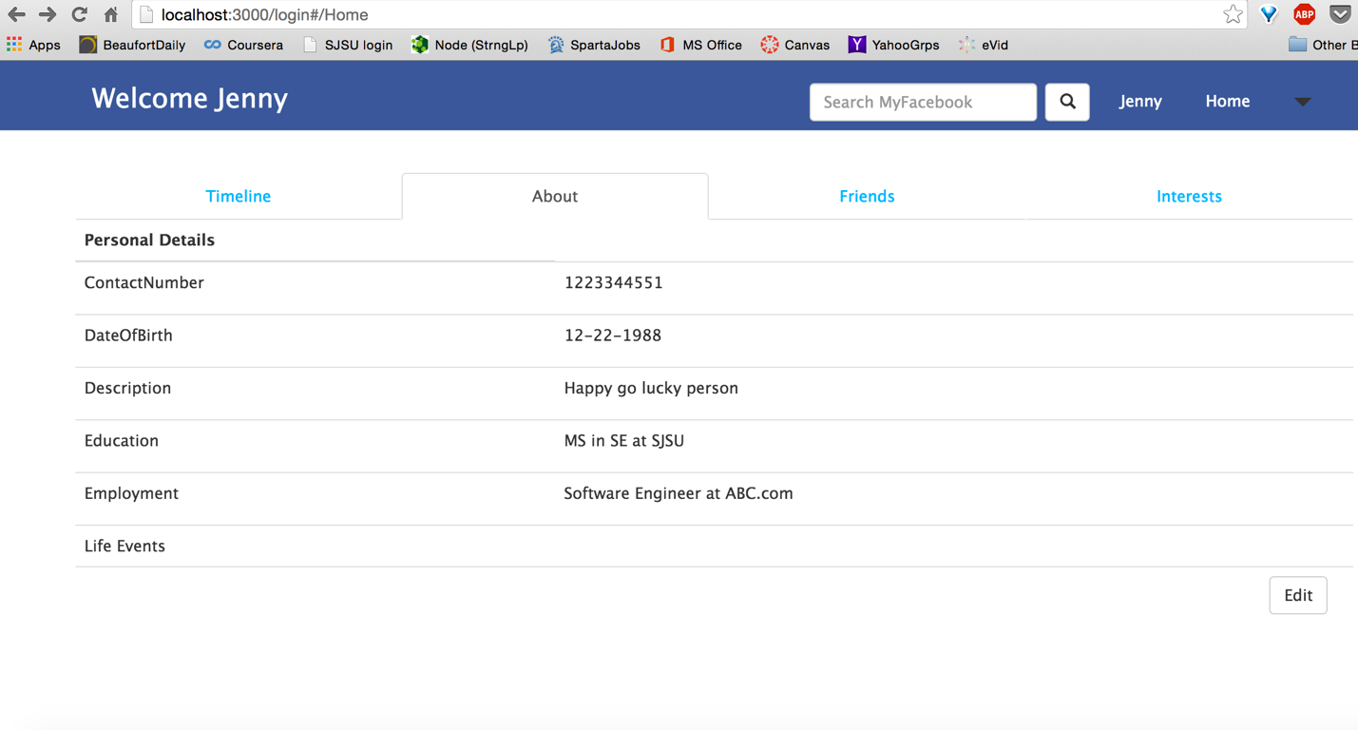

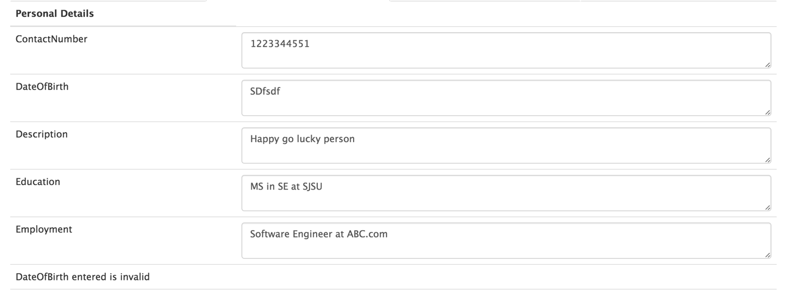

Check for incorrect DateOfBirth type implemented

Quit Edit Profile on Cancel

* + - Add Life Events (From Edit profile page)

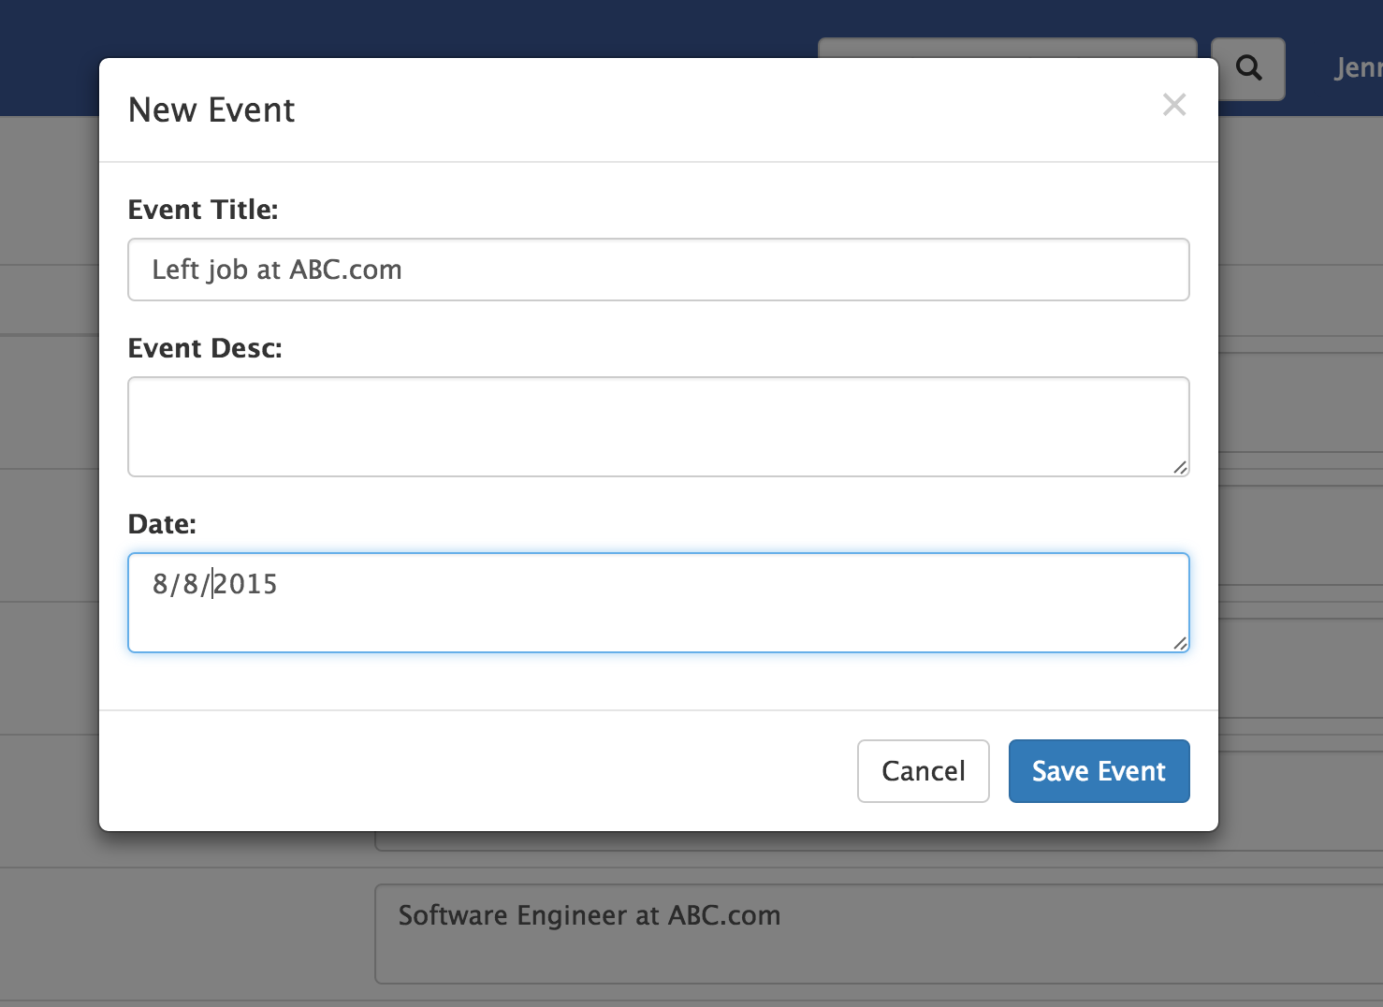

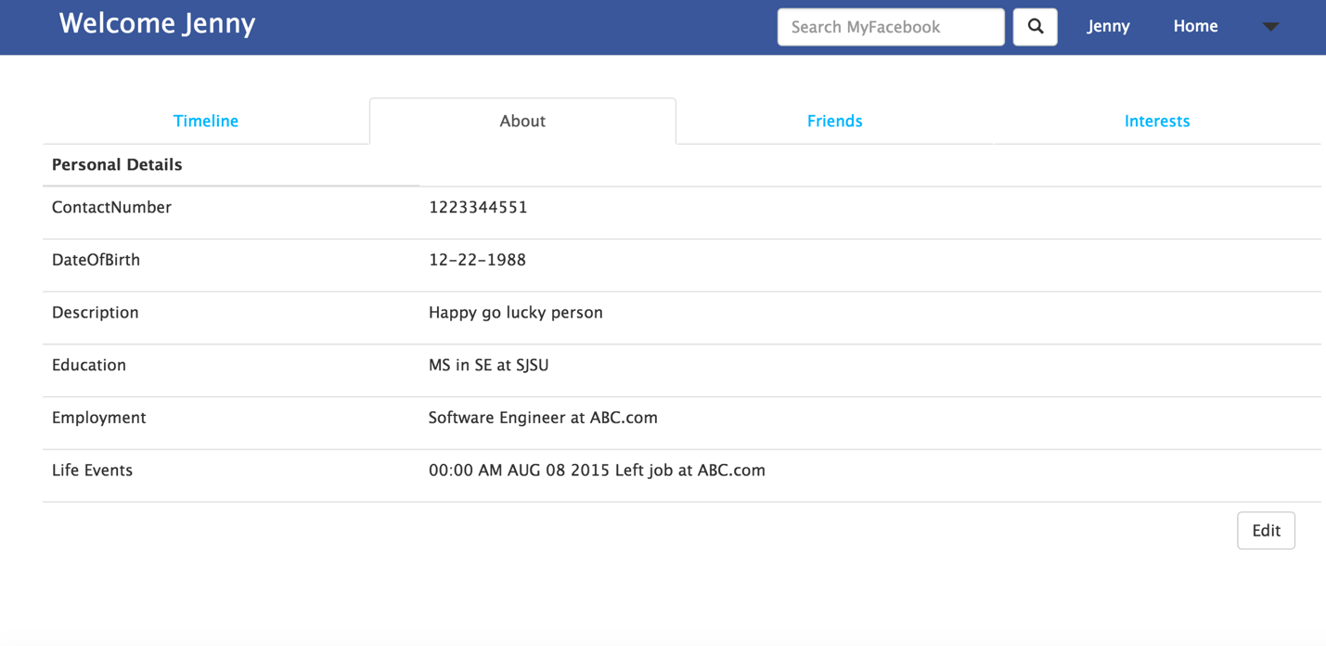

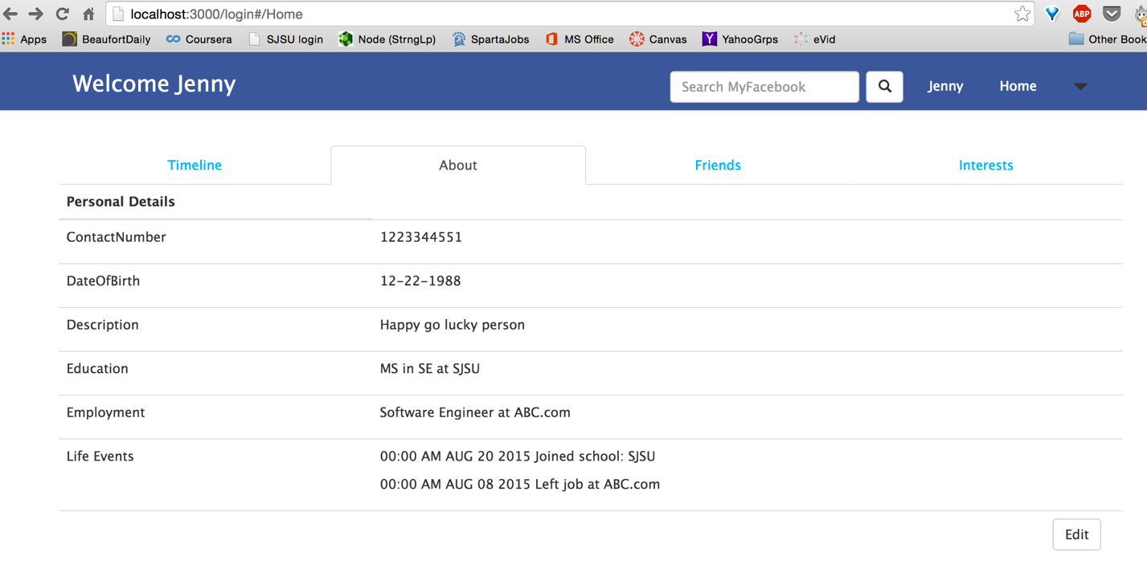

Events listed in descending order, from most recent ones at the top

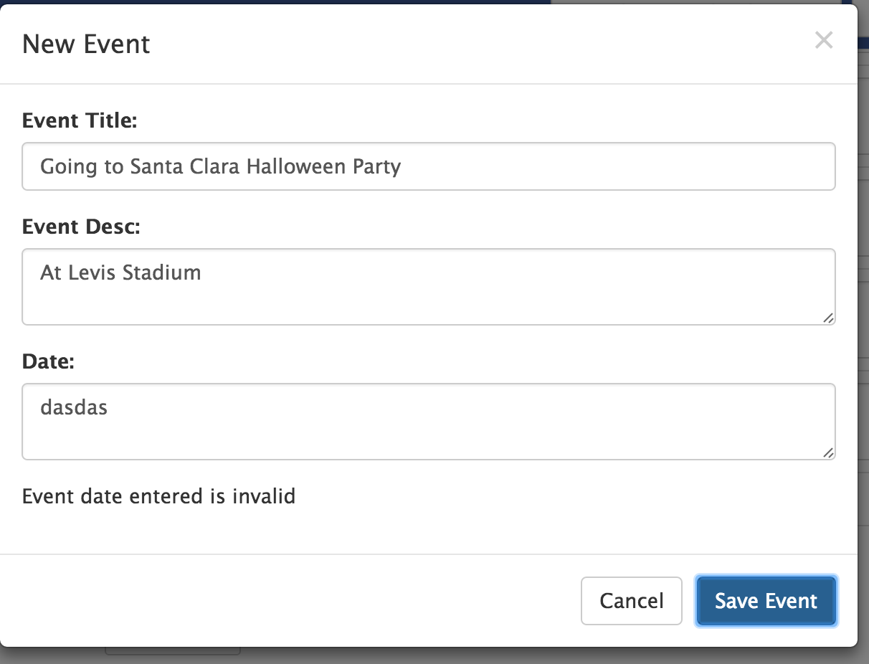

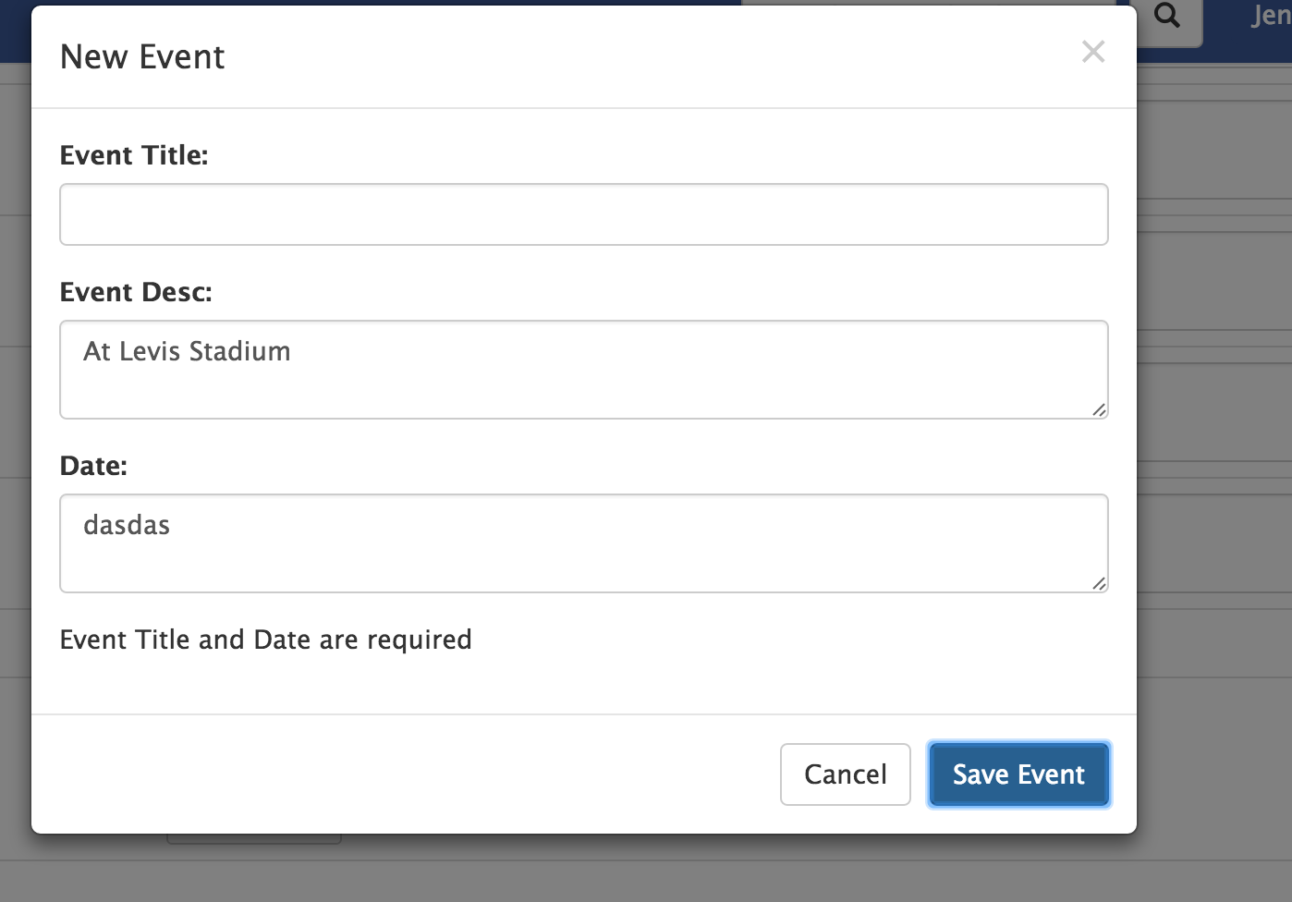

Implemented Title and Date required check, and check for valid date

* + **Friends**:
    - View his current friends’ list

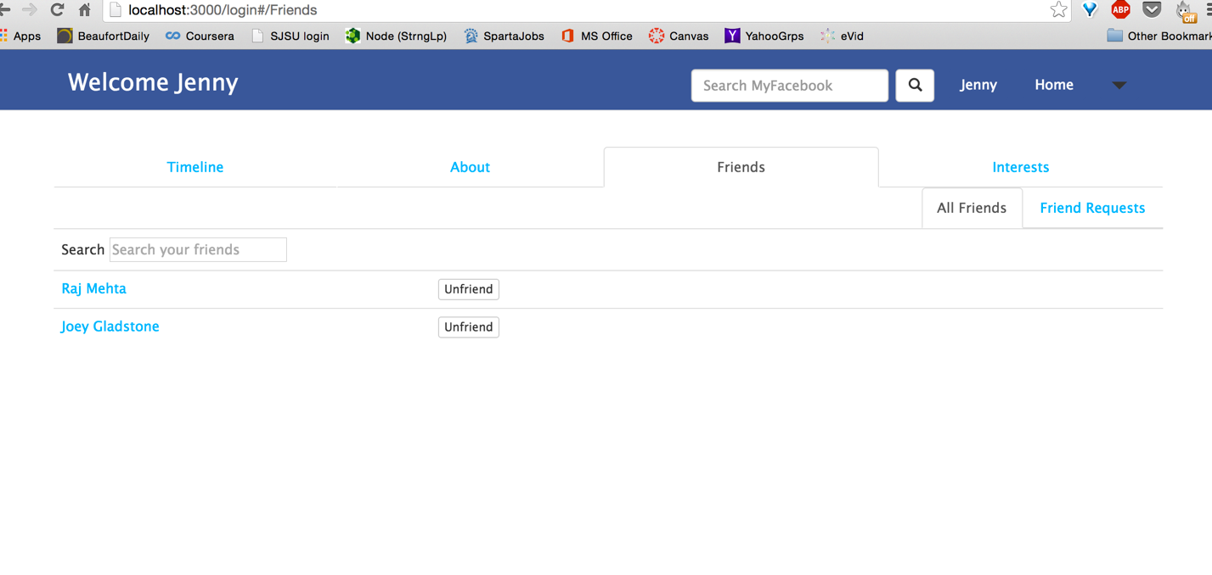

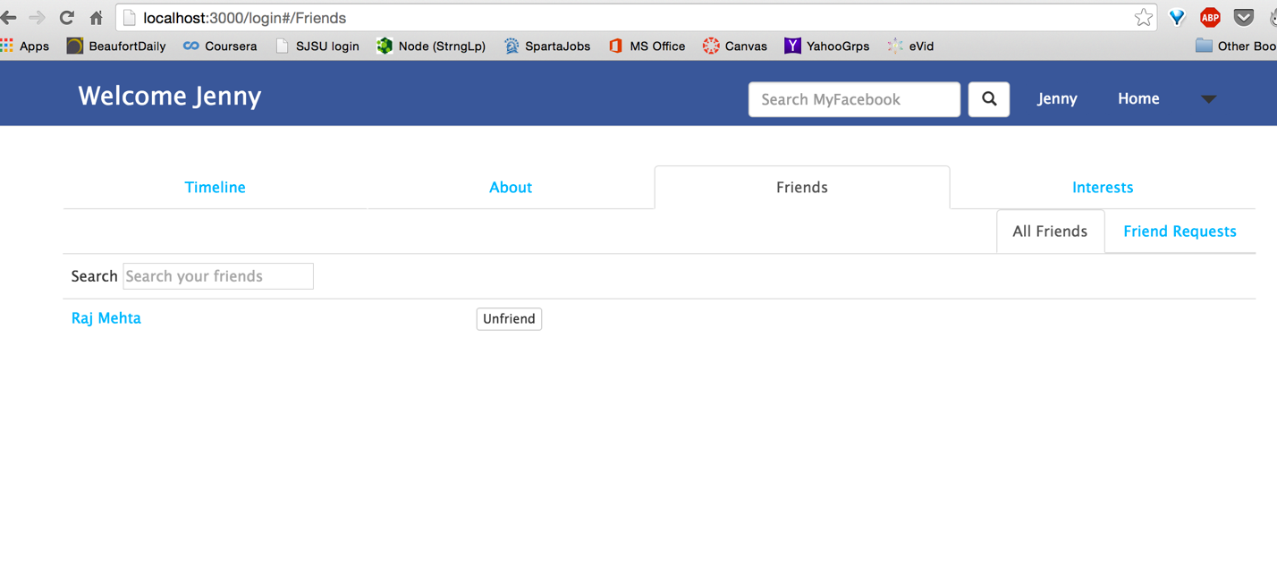

Also has an option to unfriend them

* + - View friend requests received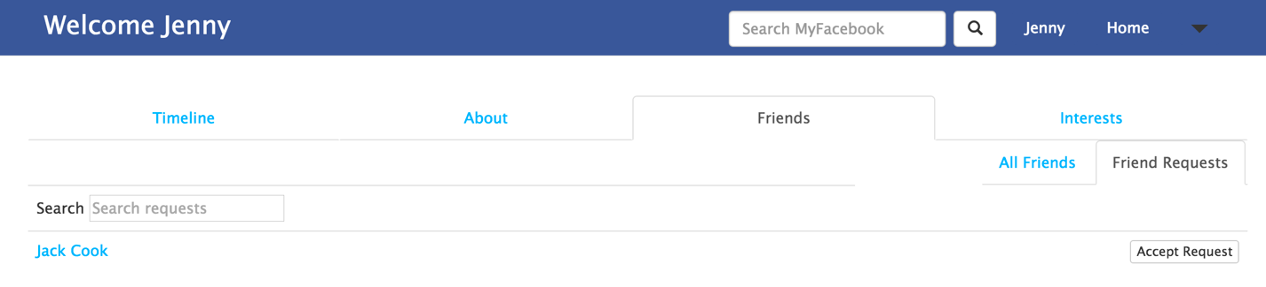
  + **Interests**:
    - View list of his interests

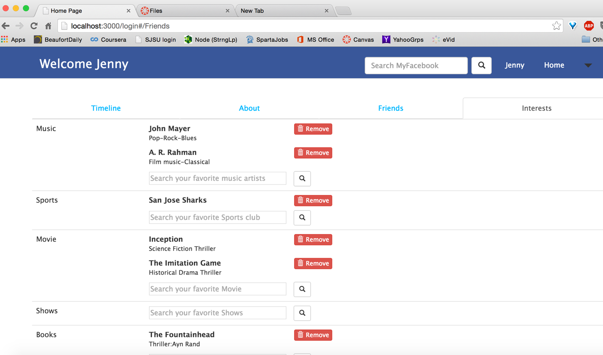

* + - Search/add new interest

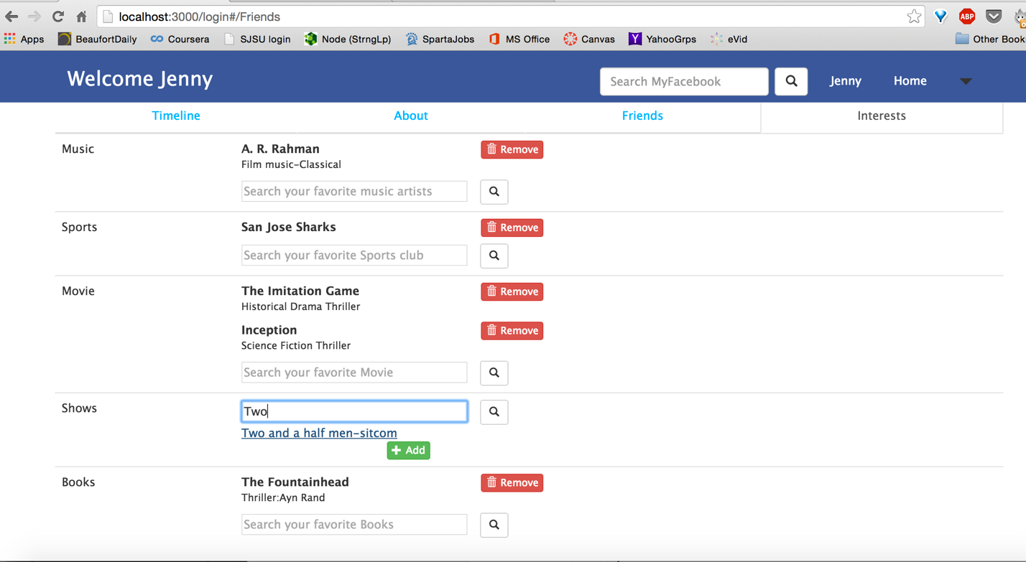

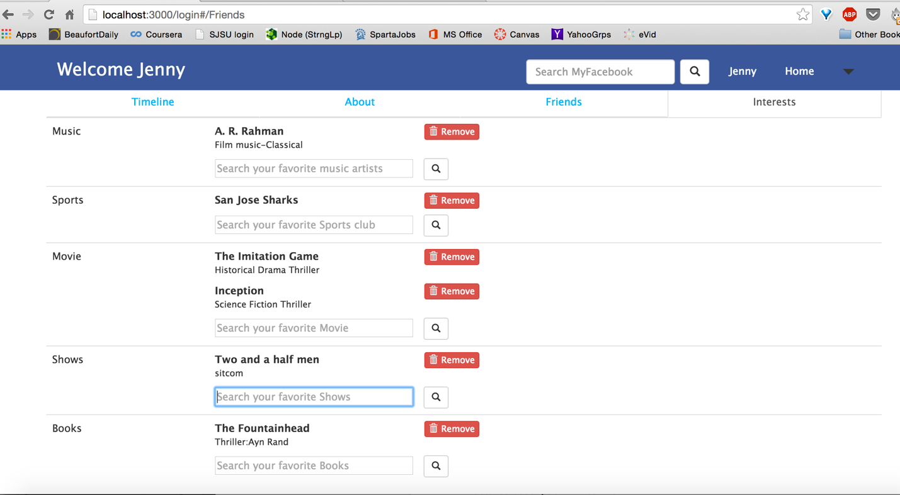

* + - Delete previous interest

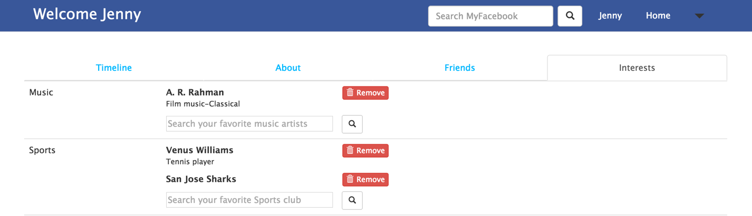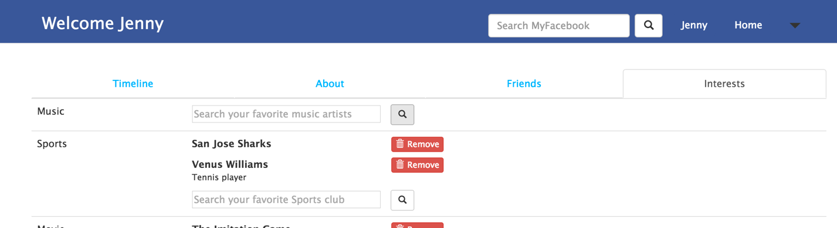

* + - Create new interest: Use option from Caret dropdown in header

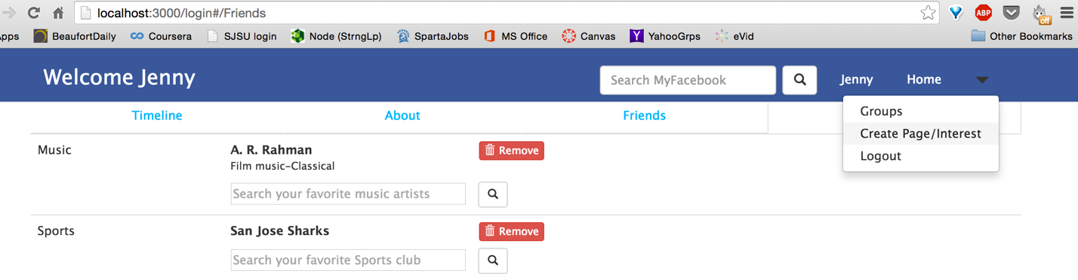

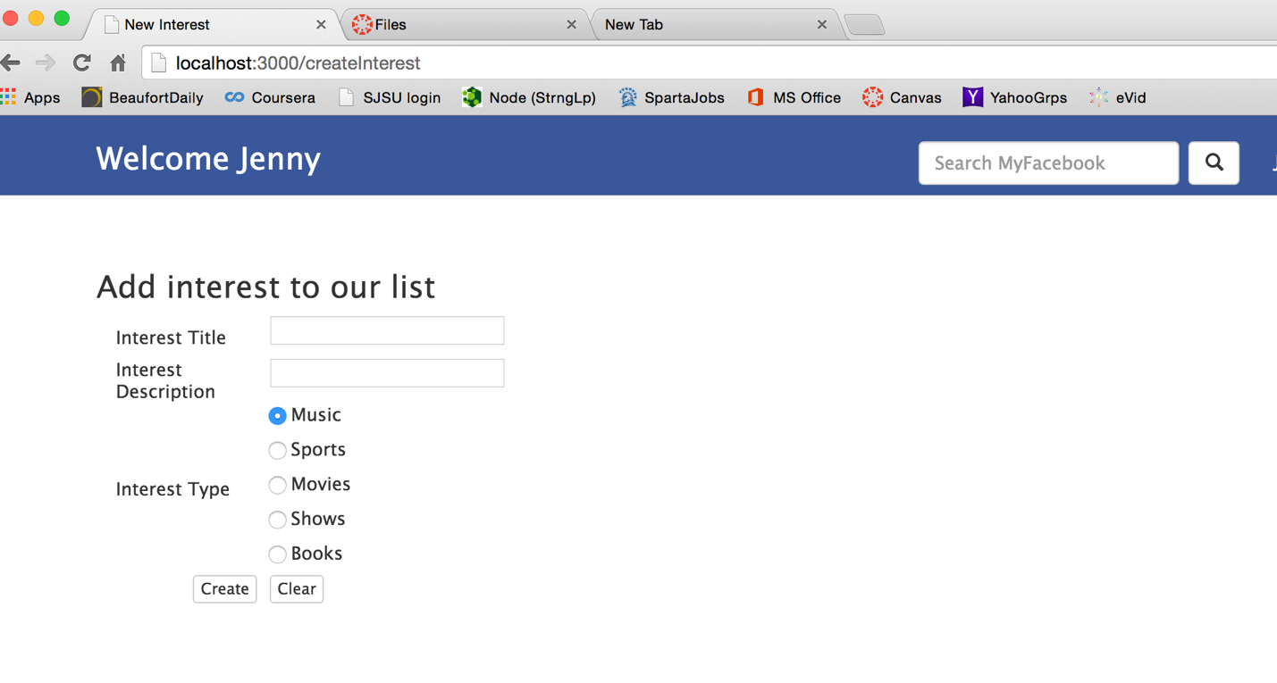

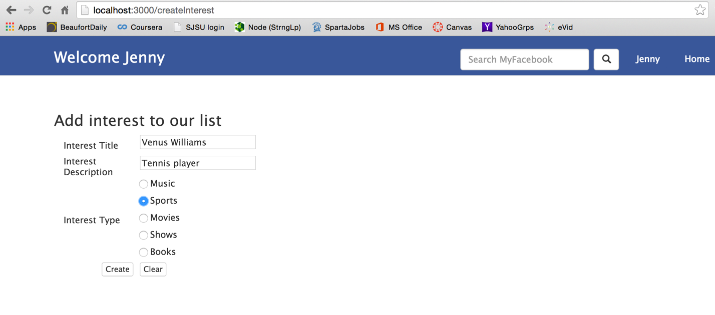

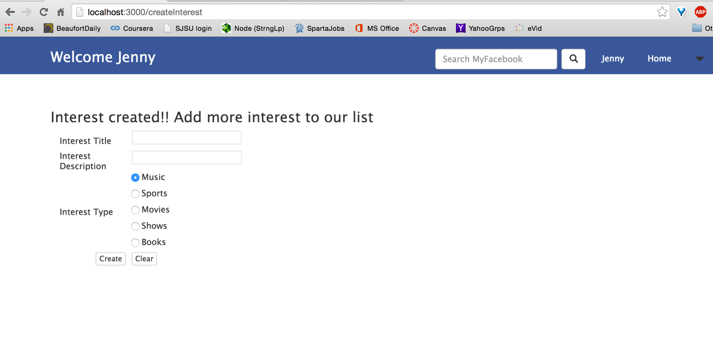

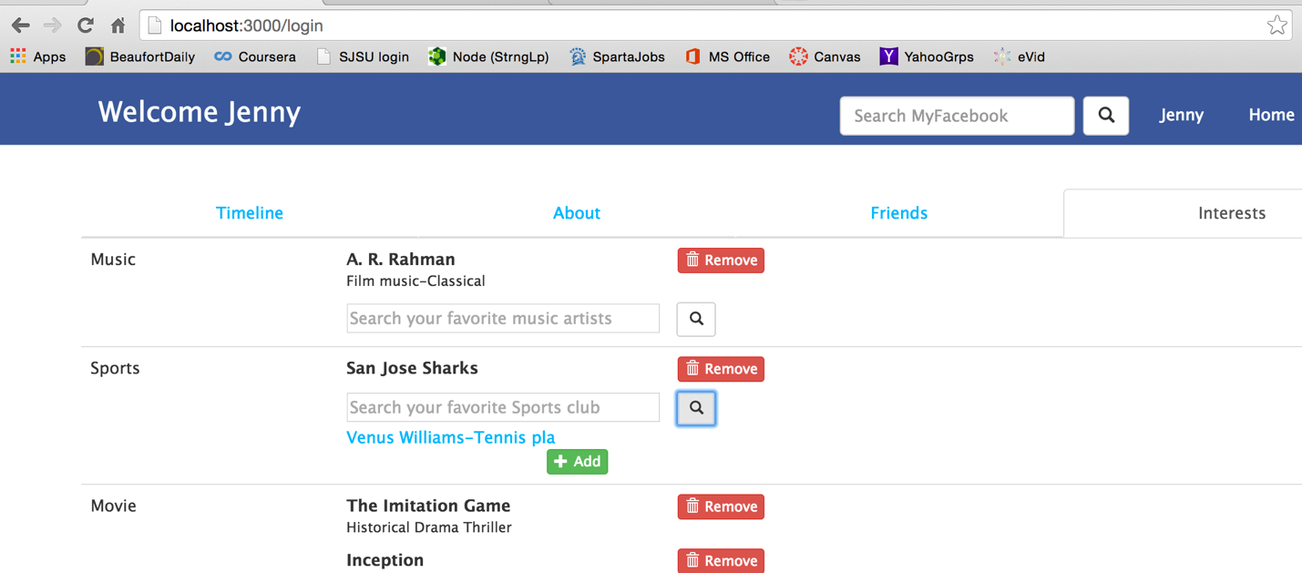

* View other users’ profile
  + View profile of users in his friend list
    - Timeline

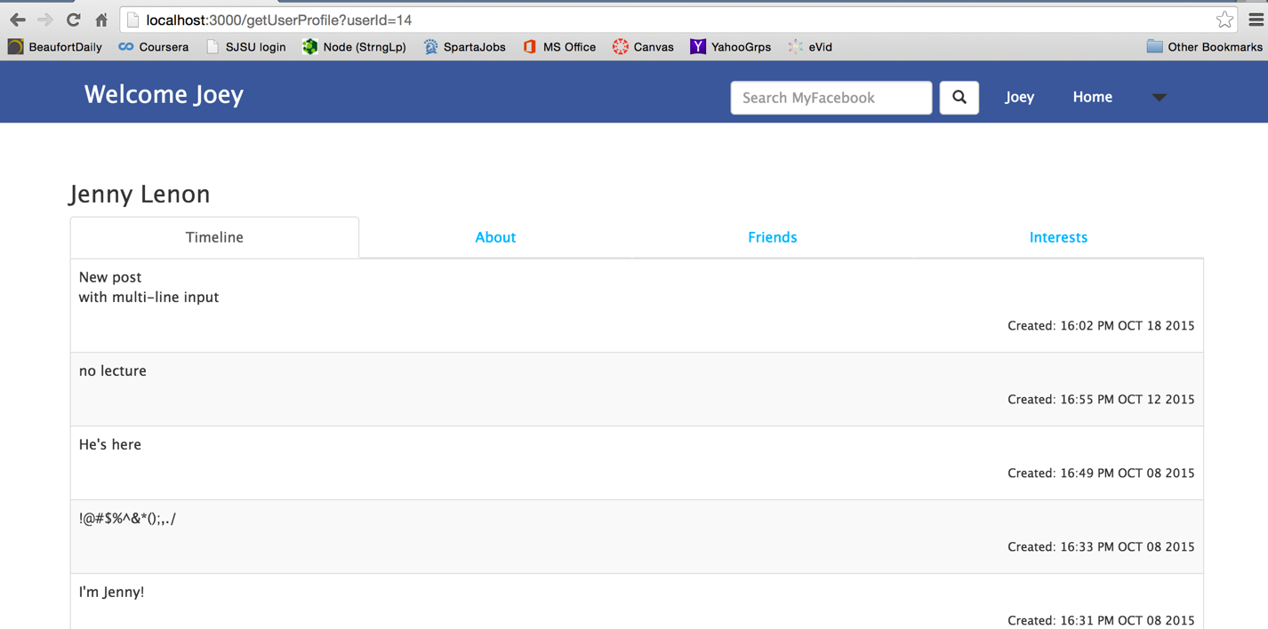

* + - Profile

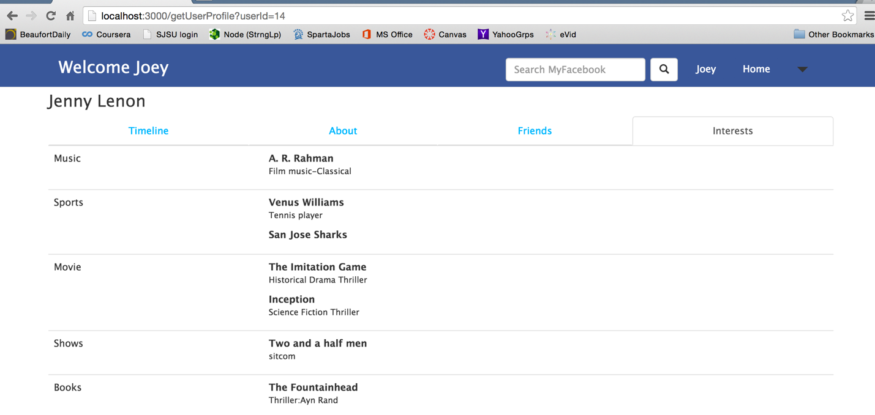

* + - Friend list

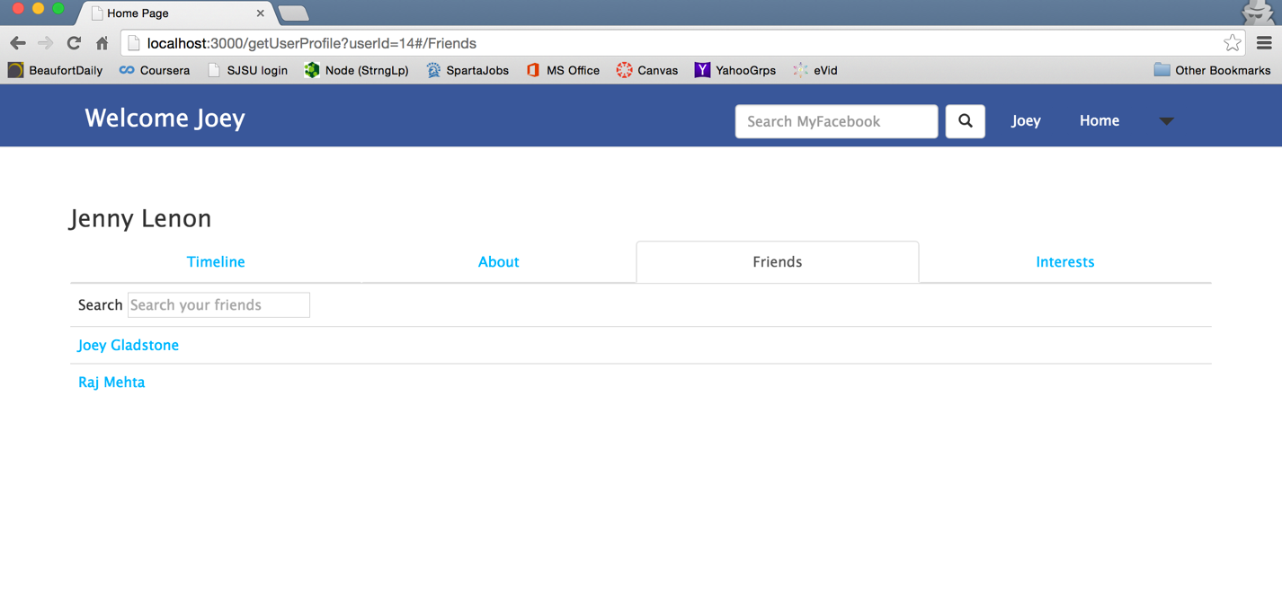

* + - Interest

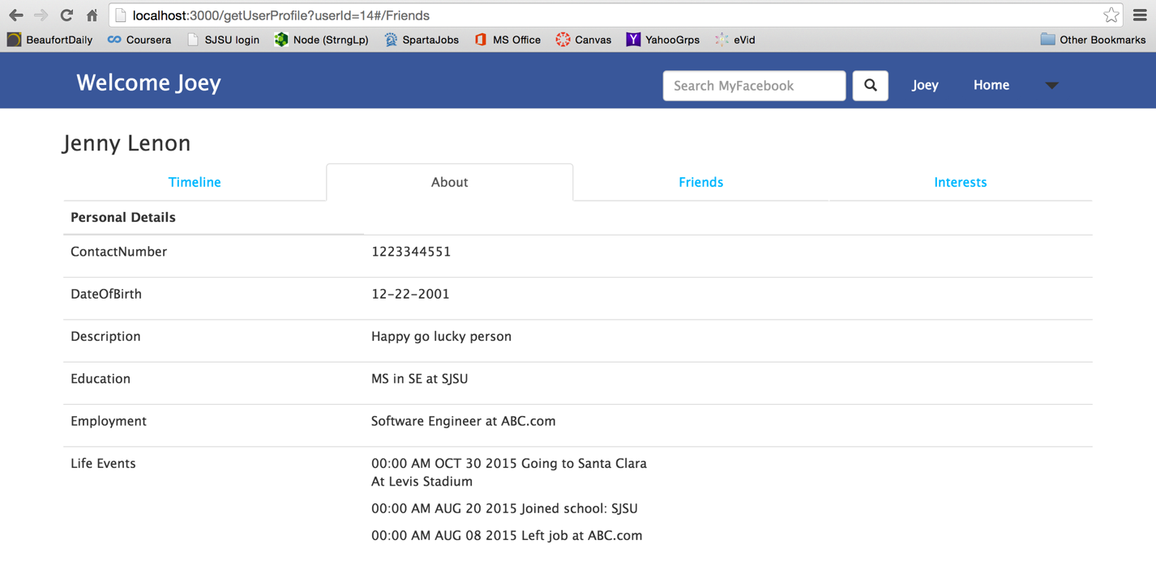

* + Send friend request to make new friends

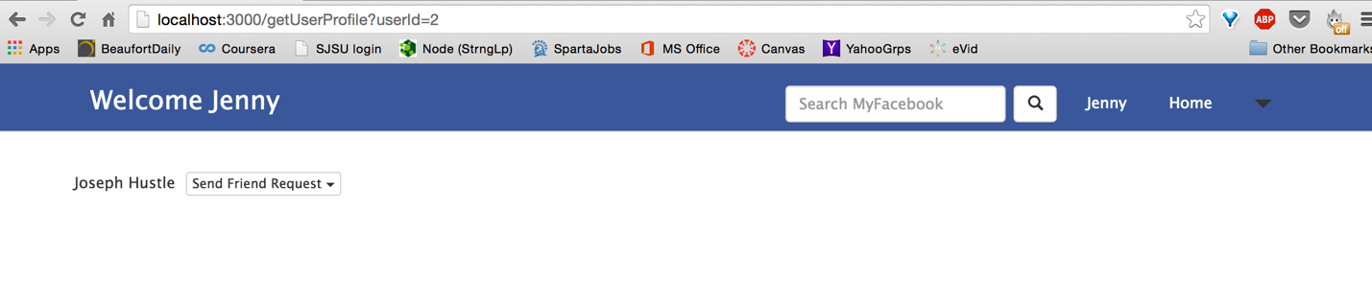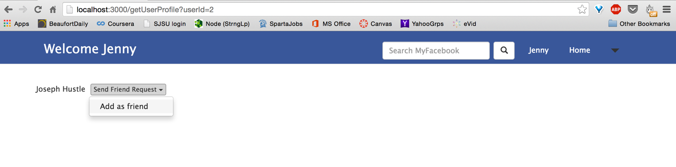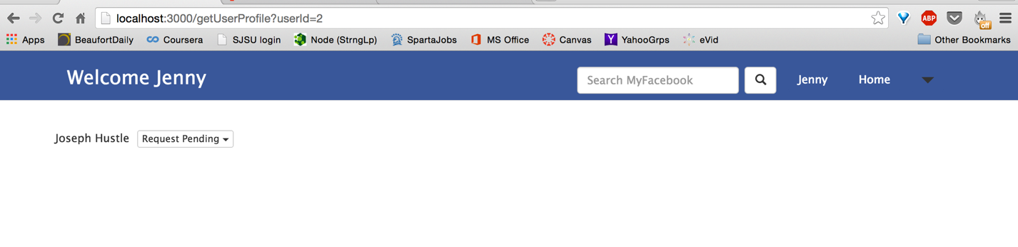

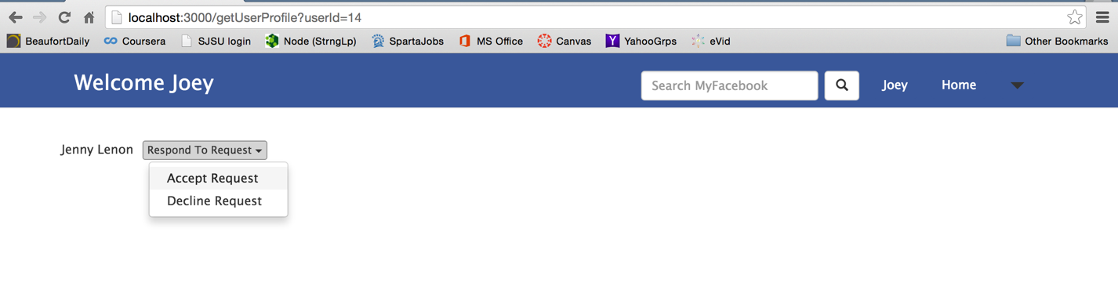



* + Search users

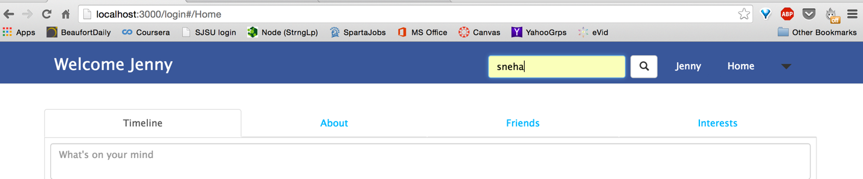

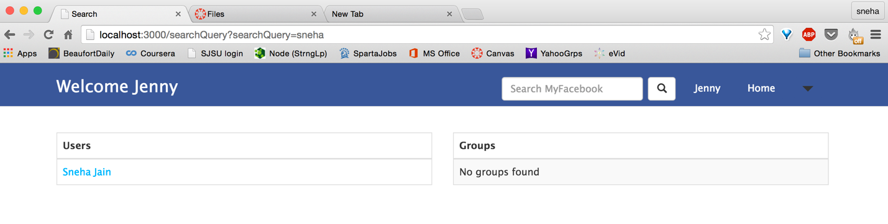

Click on the User name, it will redirect you to the user homepage if the user is your friend

* News Feed/Posts
  + View news feed from friends in his network by clicking on **Home** button in the header. Click on username (Jenny) next to the Home button to view your profile page

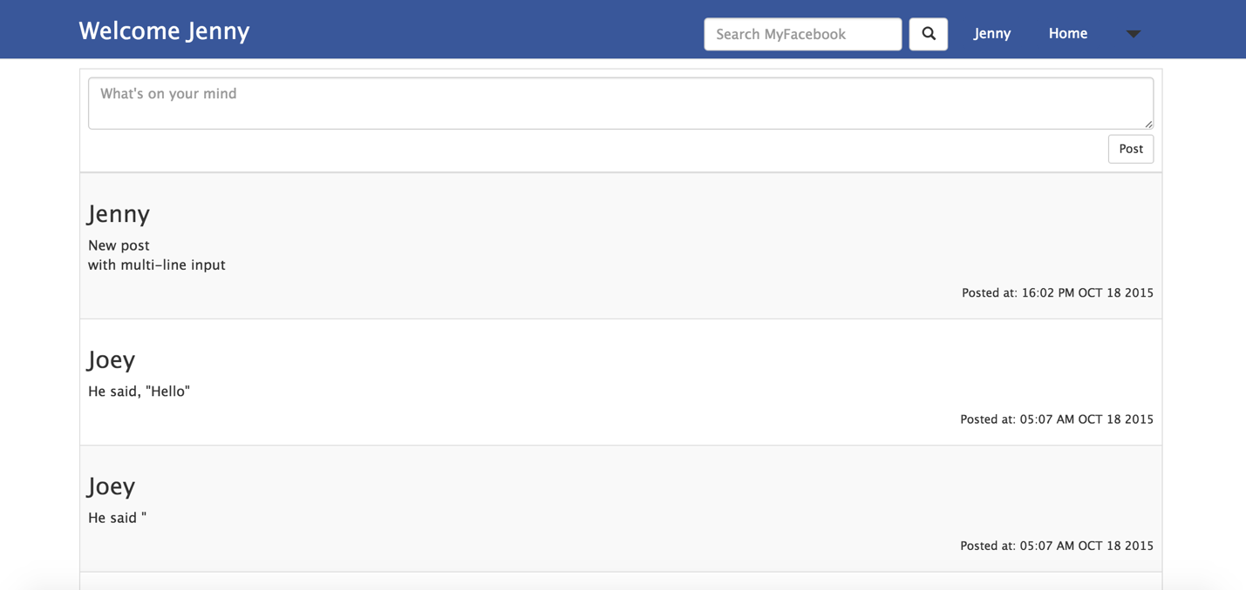

* + Create new feeds: Can create posts from News Feed page too
* Groups (Access group from dropdown option in header bar)
  + Create group: Enter name and description for group. You can also begin adding other users to the group.

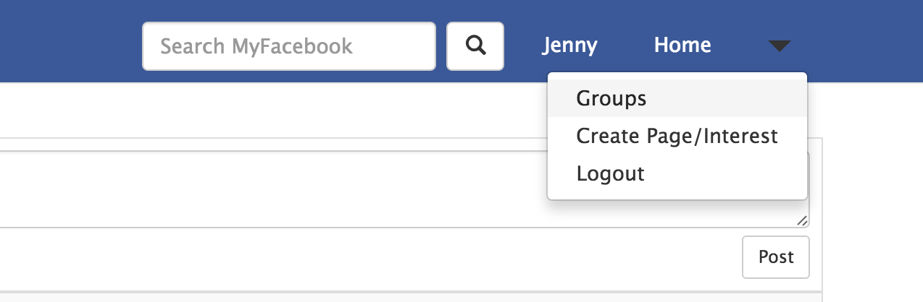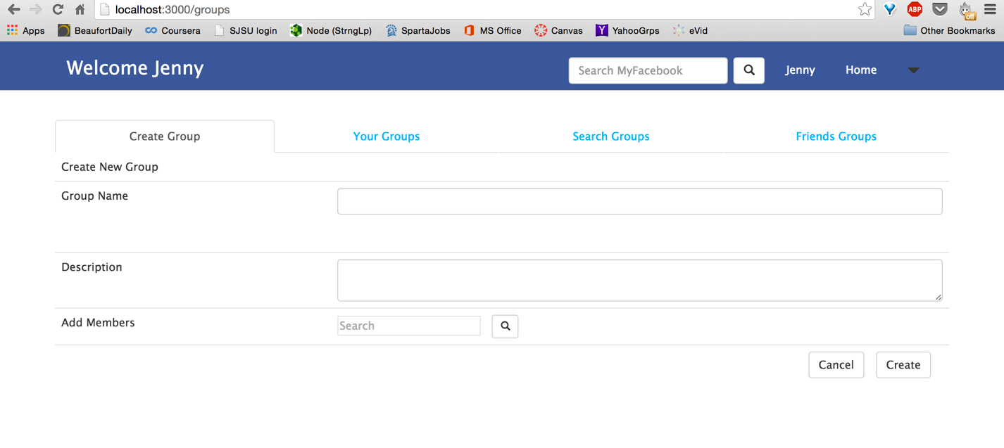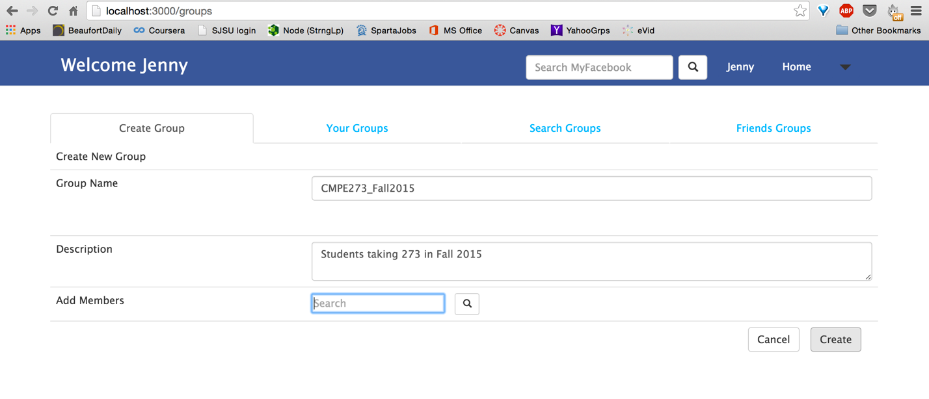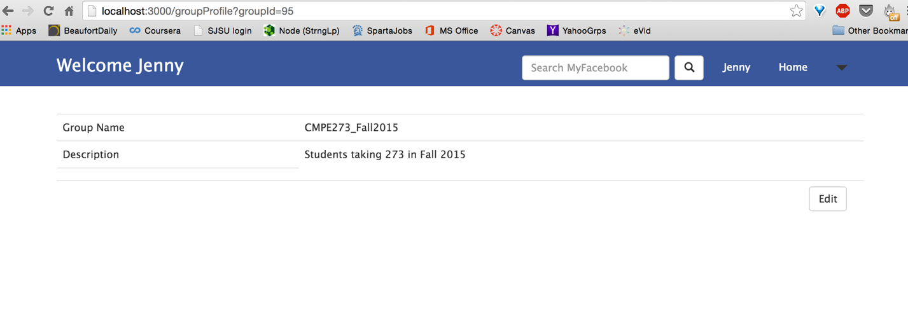

Check for empty group name implemented

* + Edit group data created by user

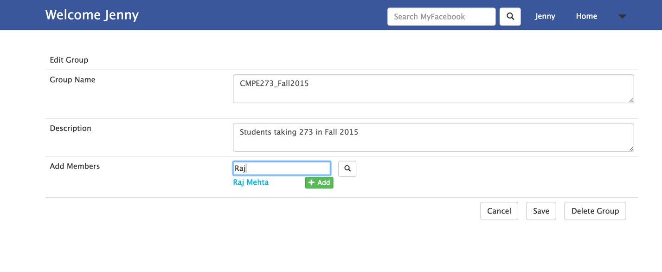

Similar to create group function, with modifications in an existing group

* + Add/Remove members from group

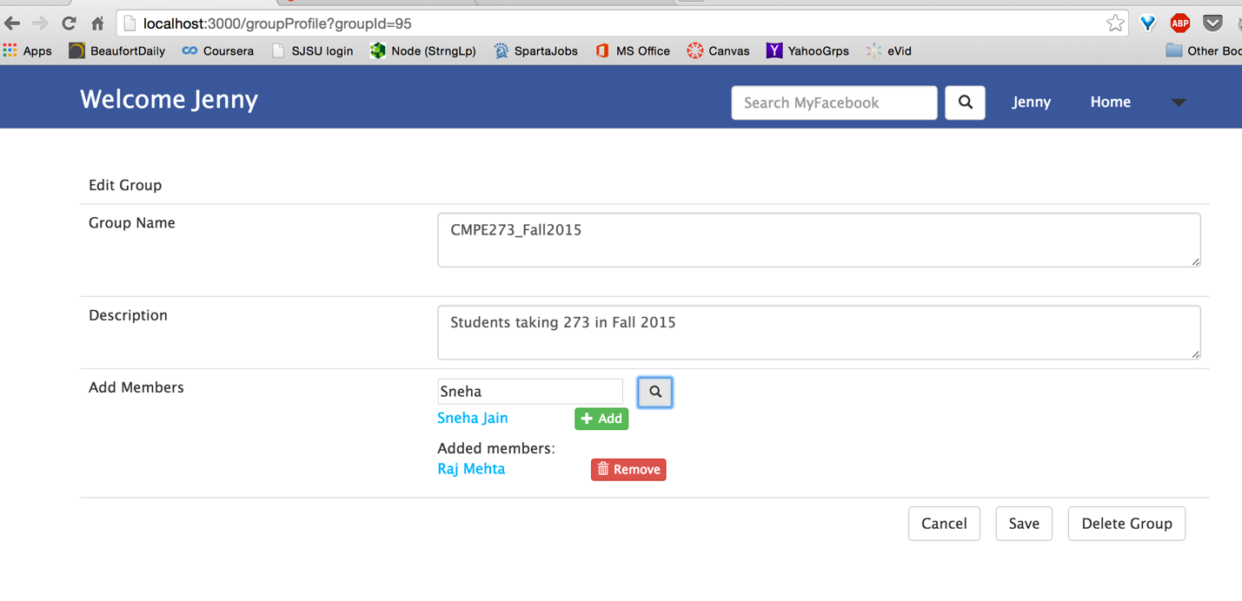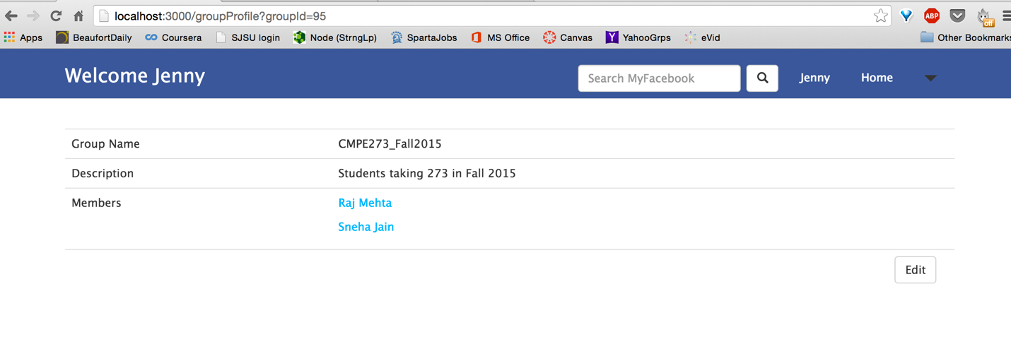

* + View user’s group

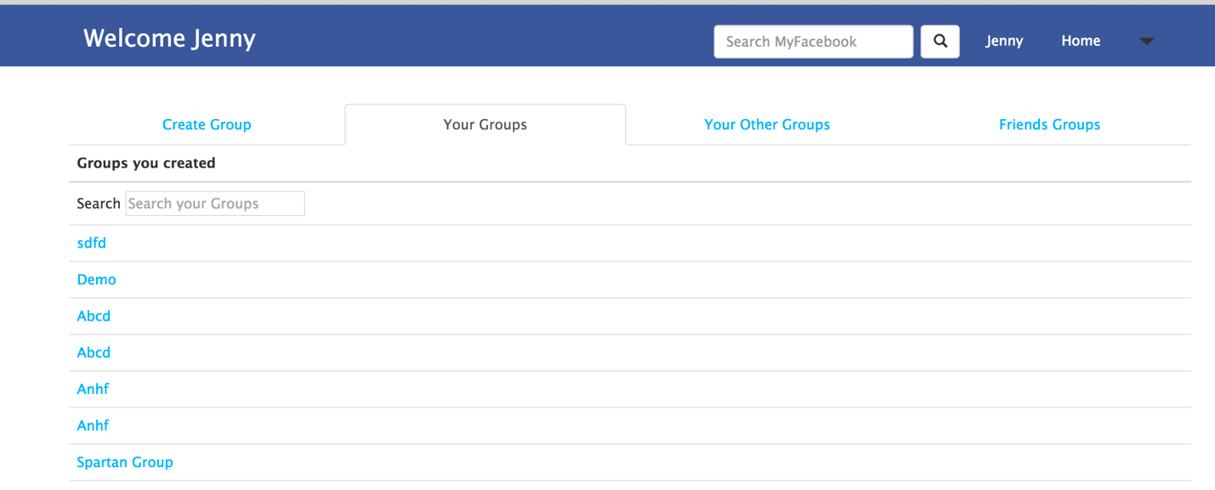

Under Your Groups section, all group created by user will be listed

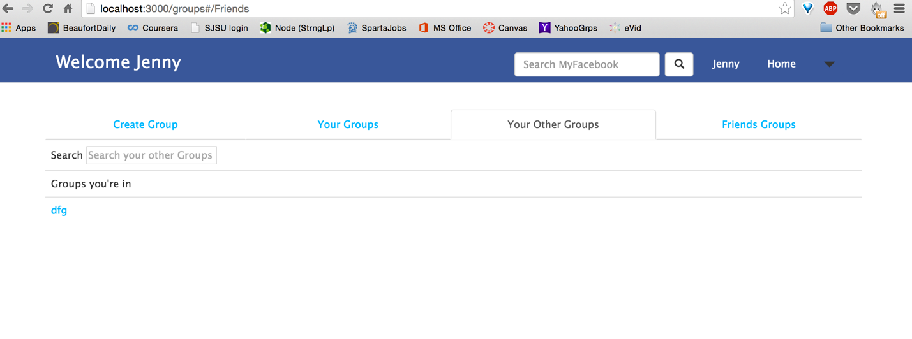

Under Your Other Groups section, all group user is a member of but not creator

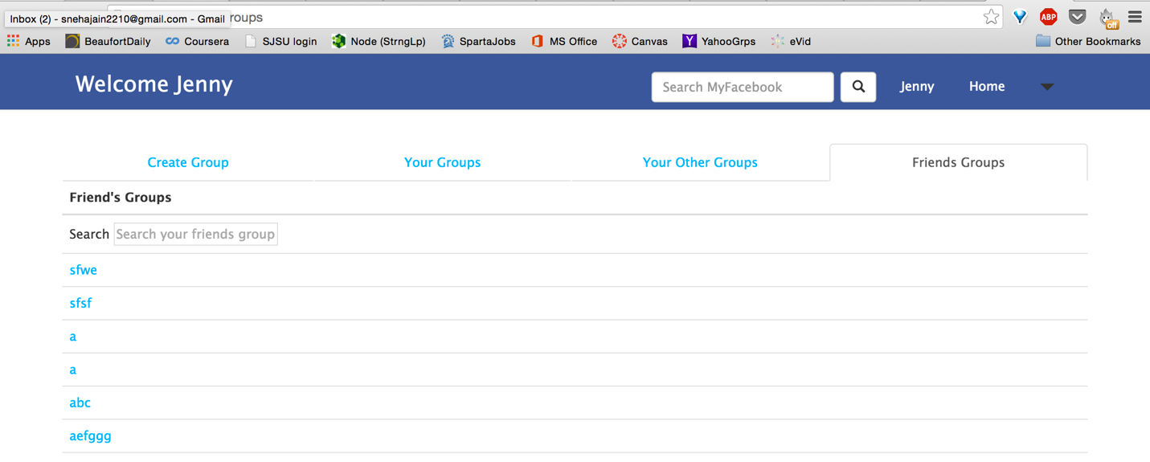

Under Friends Groups, user will get list of group suggestions that he can join based on the groups his friends are in

* + Search group

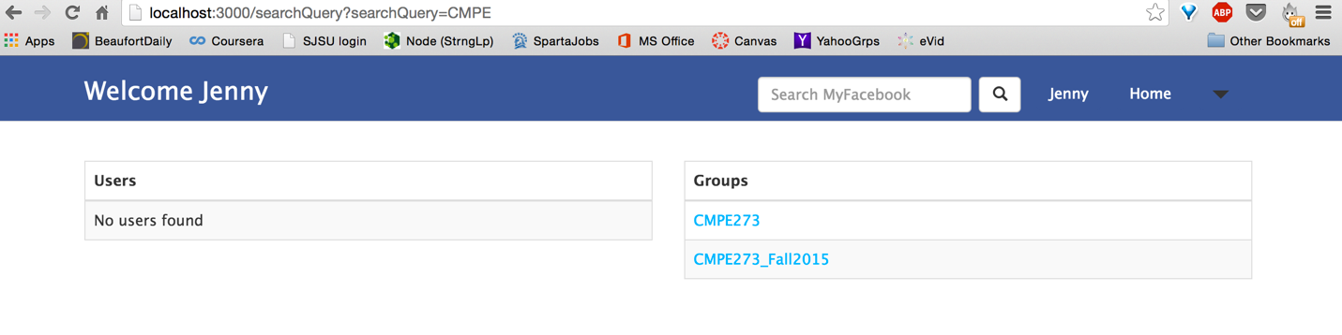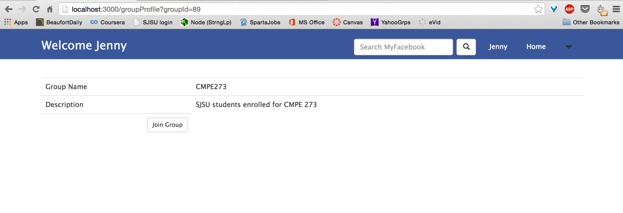Use Search MyFacebook option in the Header (similar to search user)

* + Join group

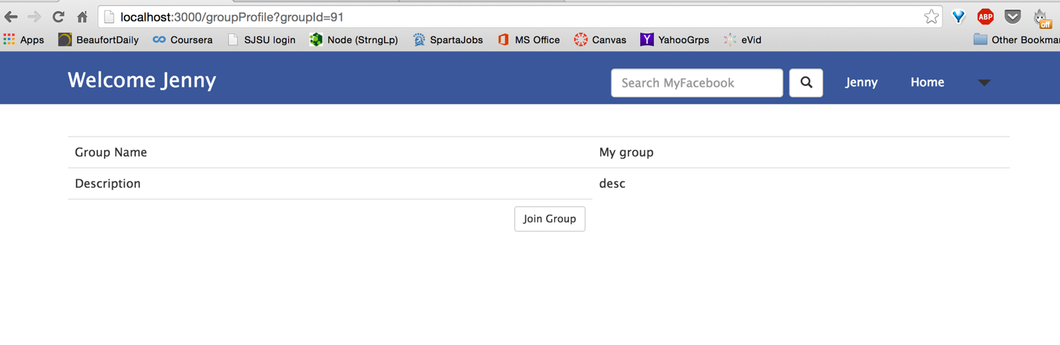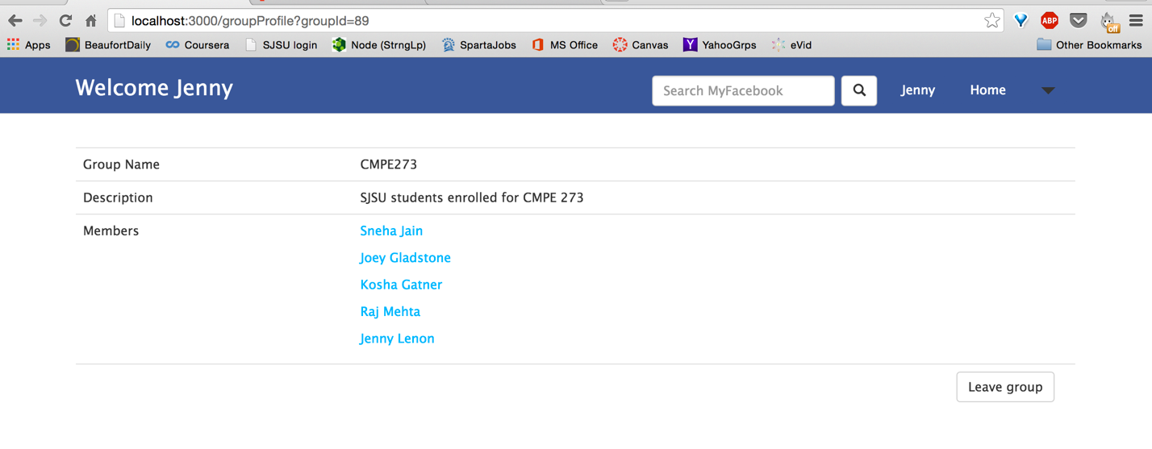

Click on any group you are not a part of, you will get a Join Group option. On joining the group, you can view its other members too

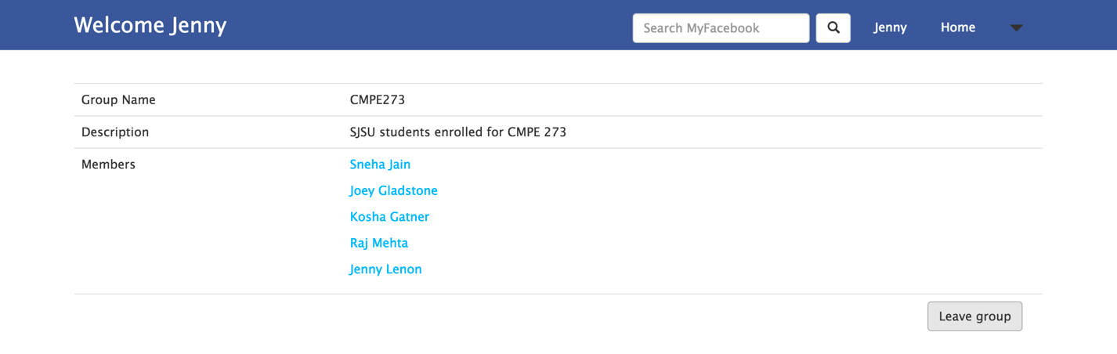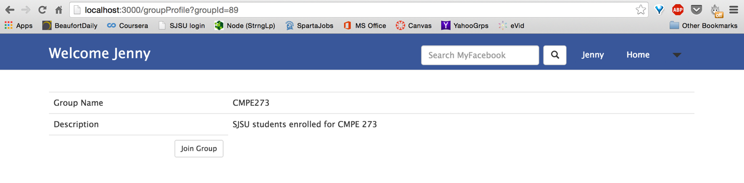You can leave a group using the Leave Group option

* + View group suggestion (View this friends groups that the user is not a part of)
* Connection Pooling: Implemented Connection pooling using connectionLimit of 500 to handle up to 500 concurrent requests and queue up to 500 additional request using the same pool.

**Performance:**

1. Calculator:

Automation: Testing using jmeter

* 1. Invoke 1,000 calculator calls on randomly selected tasks

**Time taken to perform each operation**: 20.66 millisecond

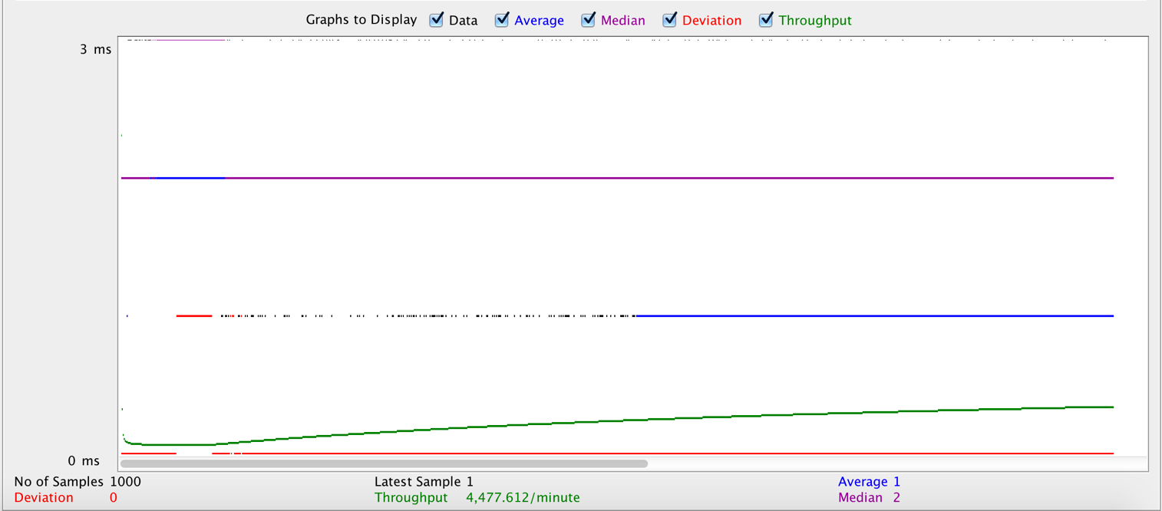**Throughput(operations per sec)**: 165.7/sec

* 1. Invoke 5,000 calculator calls on randomly selected tasks

**Time taken to perform each operation**: 6.08 millisecond

**Throughput**: 164.4/sec

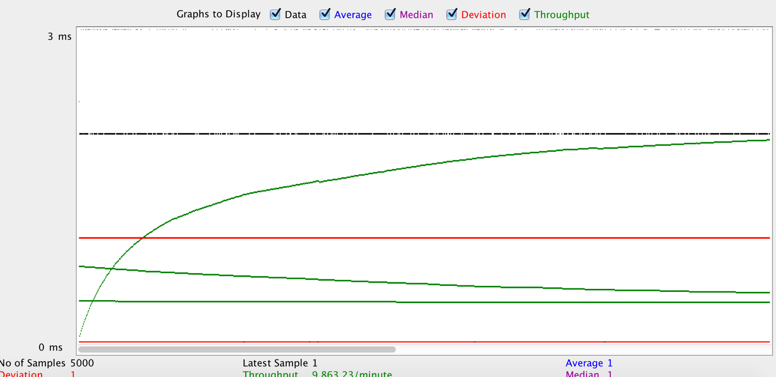

* 1. Invoke 100 concurrent users with 1000 calls each to calculator on randomly selected tasks

**Time taken to perform each operation**: 1.69 millisecond

**Throughput**: 590.6/sec

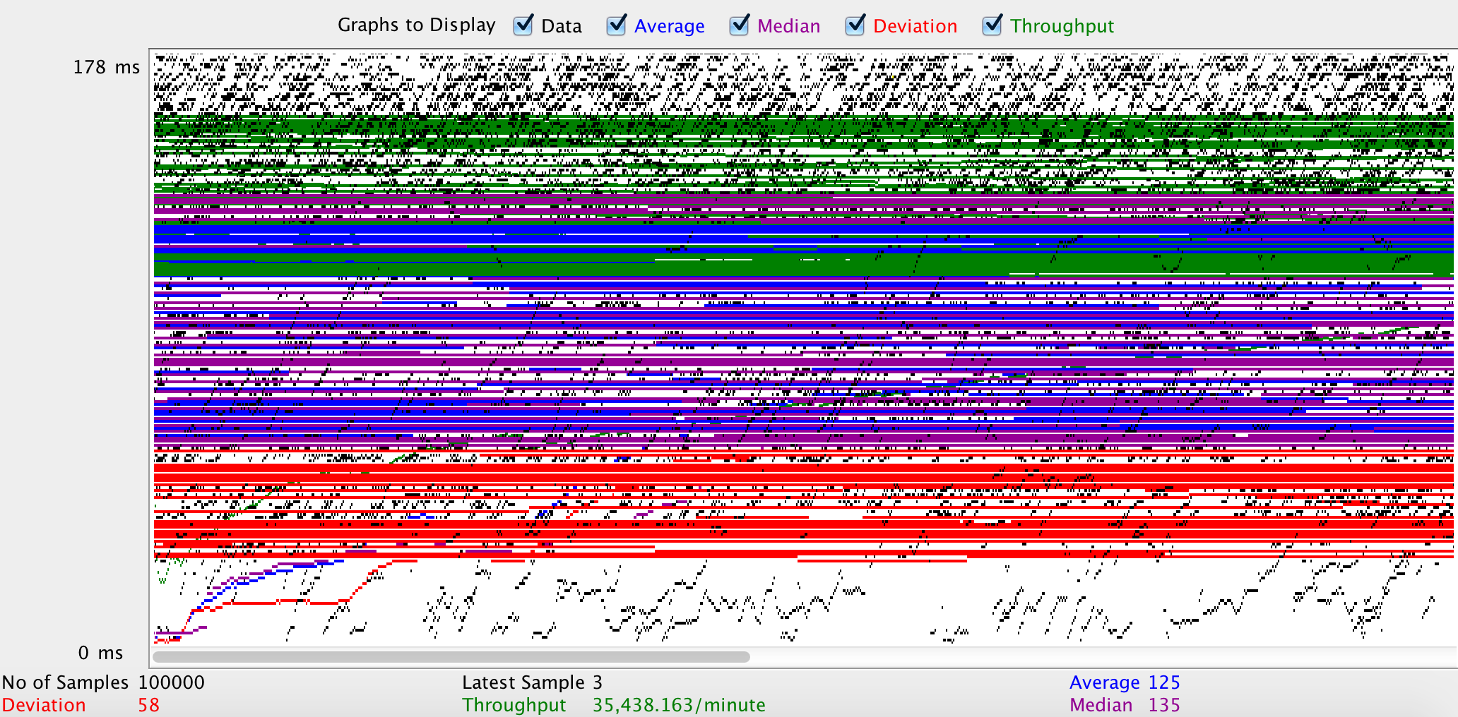

**Graph with average response time in the above 3 testing scenarios:**

**Graph comparing throughput in the above 3 testing scenarios:**

Figure 2

In case I and II, multiple calls to the server are being made through one connection (1 user). Whereas in Case III, calls are being made through 100 concurrent connections. Since the server can handle these many concurrent calls, each connection is handled simultaneously/independently. Thus, improving the throughput of the server. Results of Case I and II are similar since the number of calls over one connection has increased, not the number of connections.

1. Facebook application

Load testing using jmeter: Made 100, 200, 300, 400 and 500 concurrent calls to the application with and without connection pooling.

|  |  |  |  |  |  |
| --- | --- | --- | --- | --- | --- |
| **Throughput** | 100 | 200 | 300 | 400 | 500 |
| **With connection pooling** | 98.8/sec | 194.6/sec | 273.0/sec | 351.8/sec | 397.5/sec |
| **Without Connection Pooling** | 97.7/sec | 184.4/sec | 256.0/sec | 285.2/sec | 300.7/sec |

Connection pooling improves response time because database connection is not made every-time a database request is made. A pool of connection is maintained and every request is made, a resource from the pool is assigned respond to that request.

The green line in the above chart shows the percent change in response time when testing without connection pooling and with connection pooling. The average response time improved by 32% and improvement is more evident when the number of concurrent calls increase.

Throughput Graphs with Connection Pooling

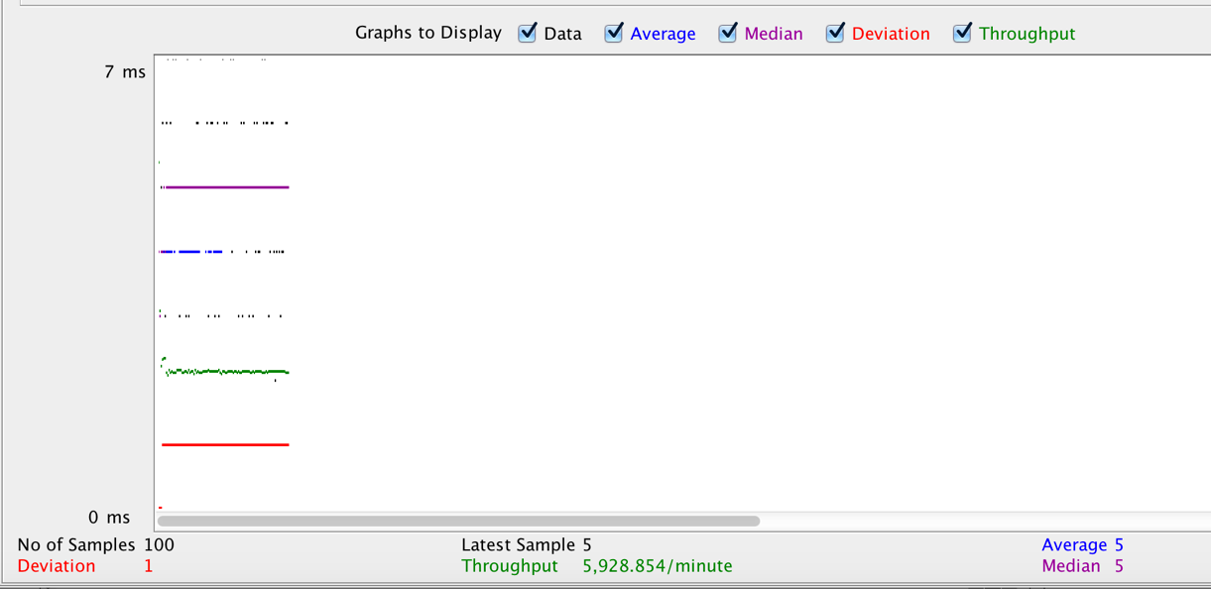100 concurrent calls

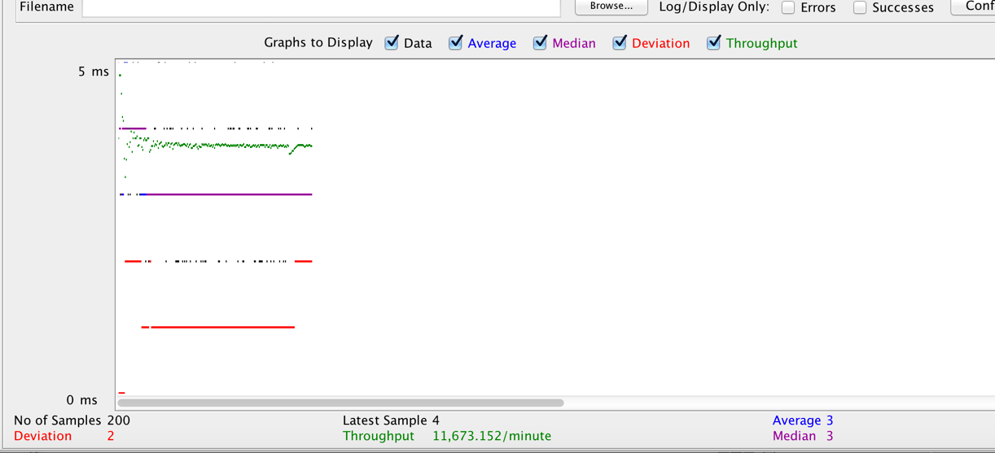200 concurrent calls

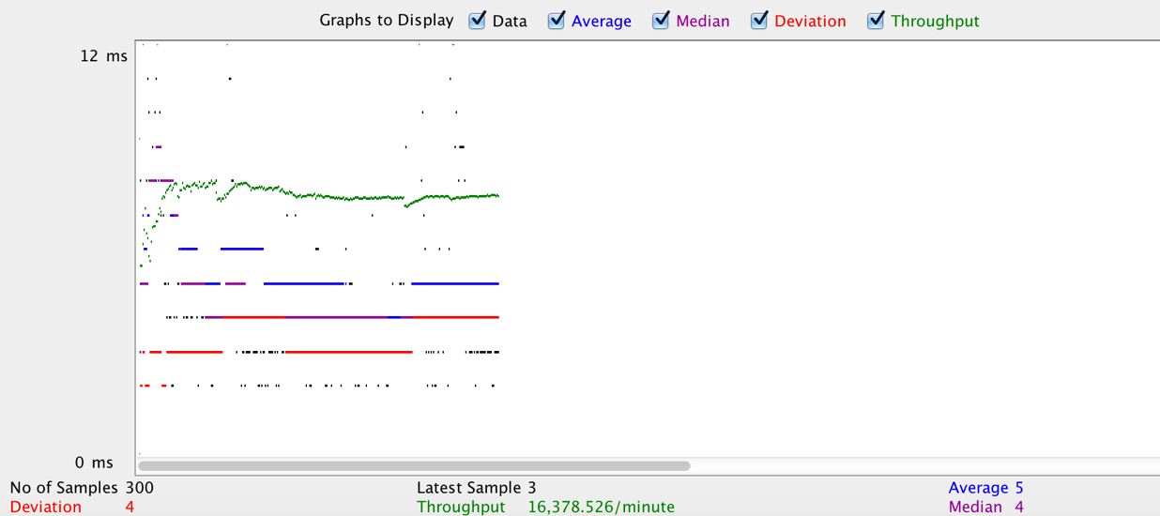300 concurrent calls

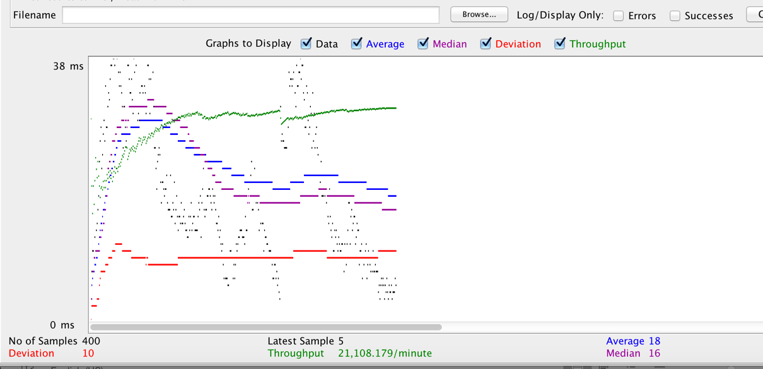

400 concurrent calls

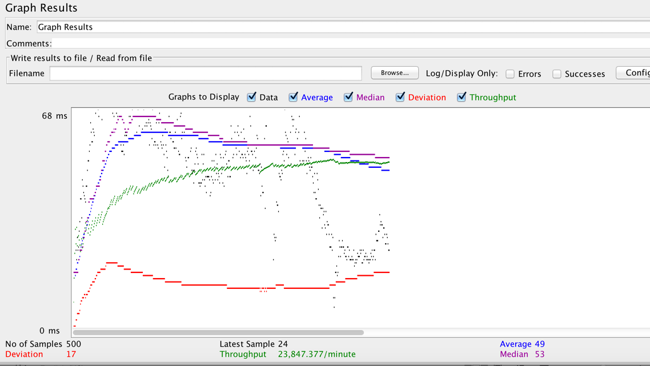500 concurrent calls

Throughput Graphs Without Connection Pooling

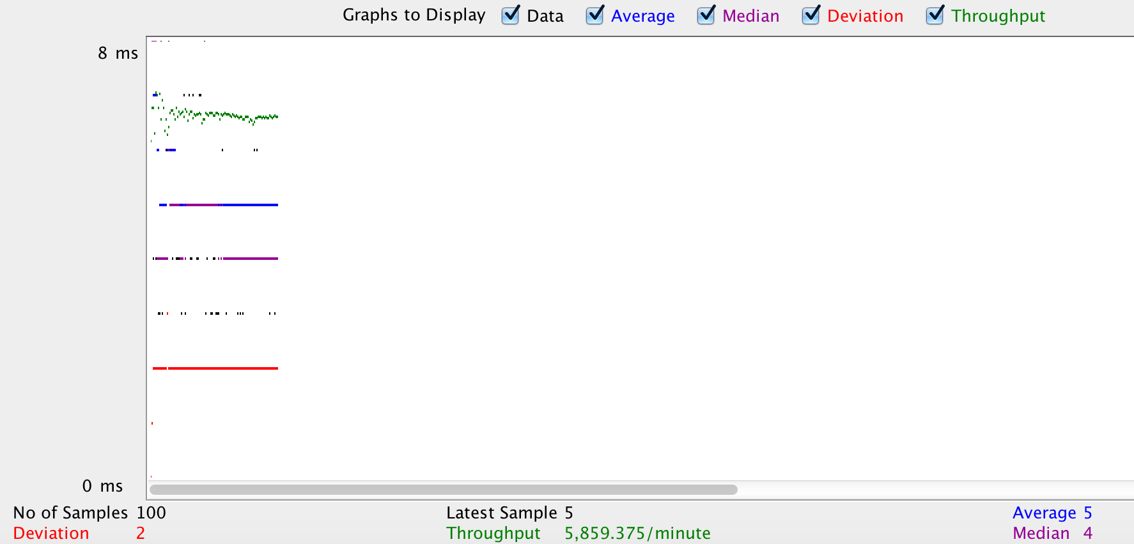

100 calls without CP

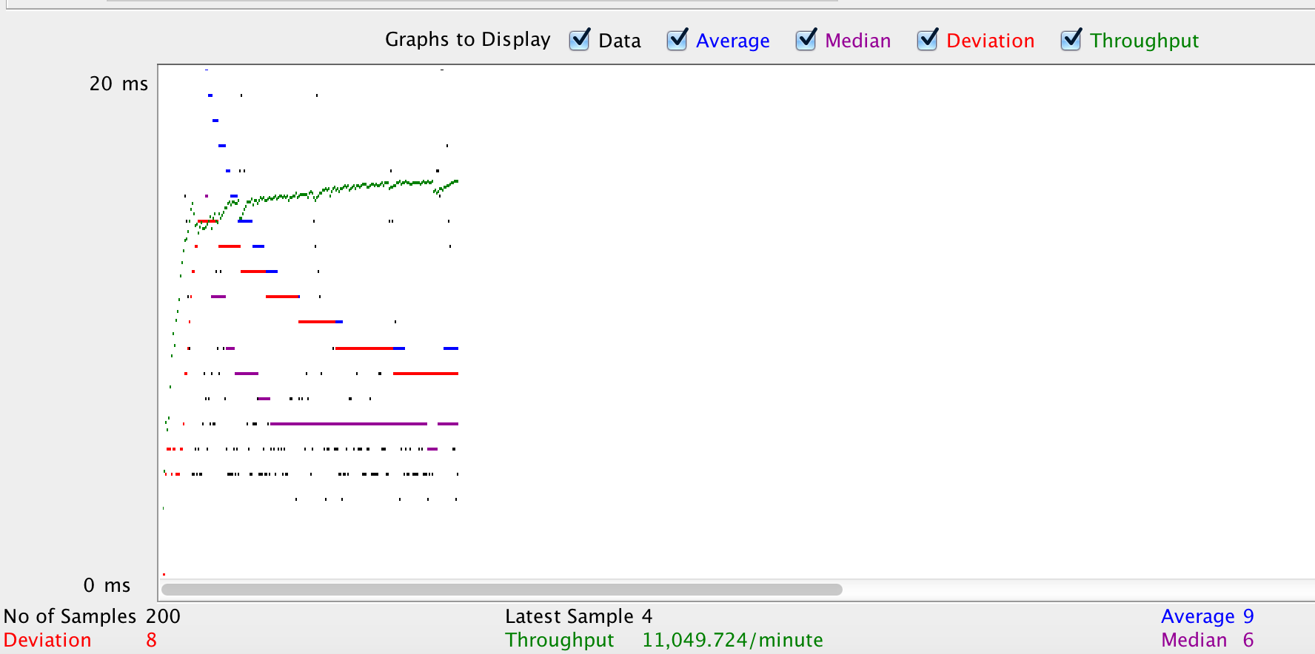

200 calls without CP

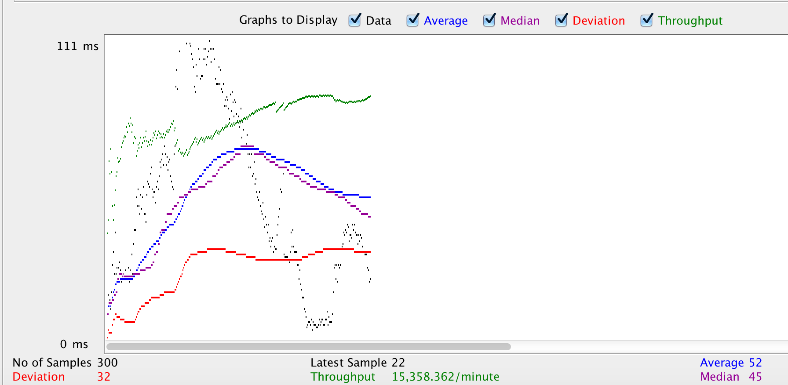300 calls without CP

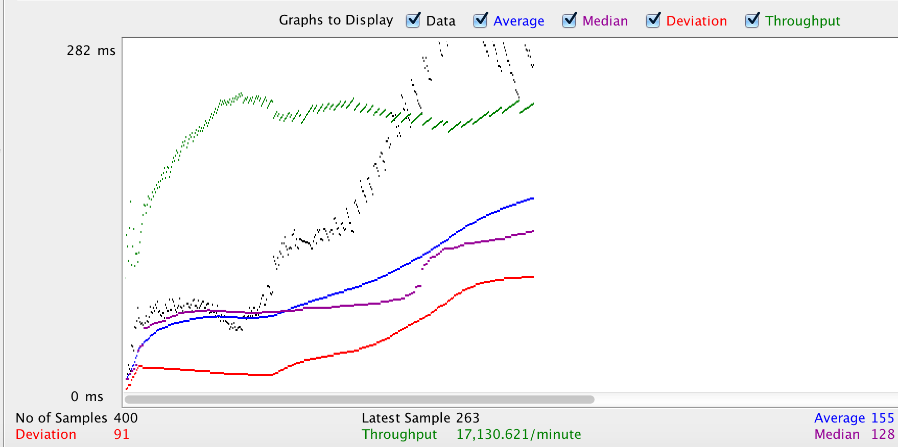

400 calls without CP

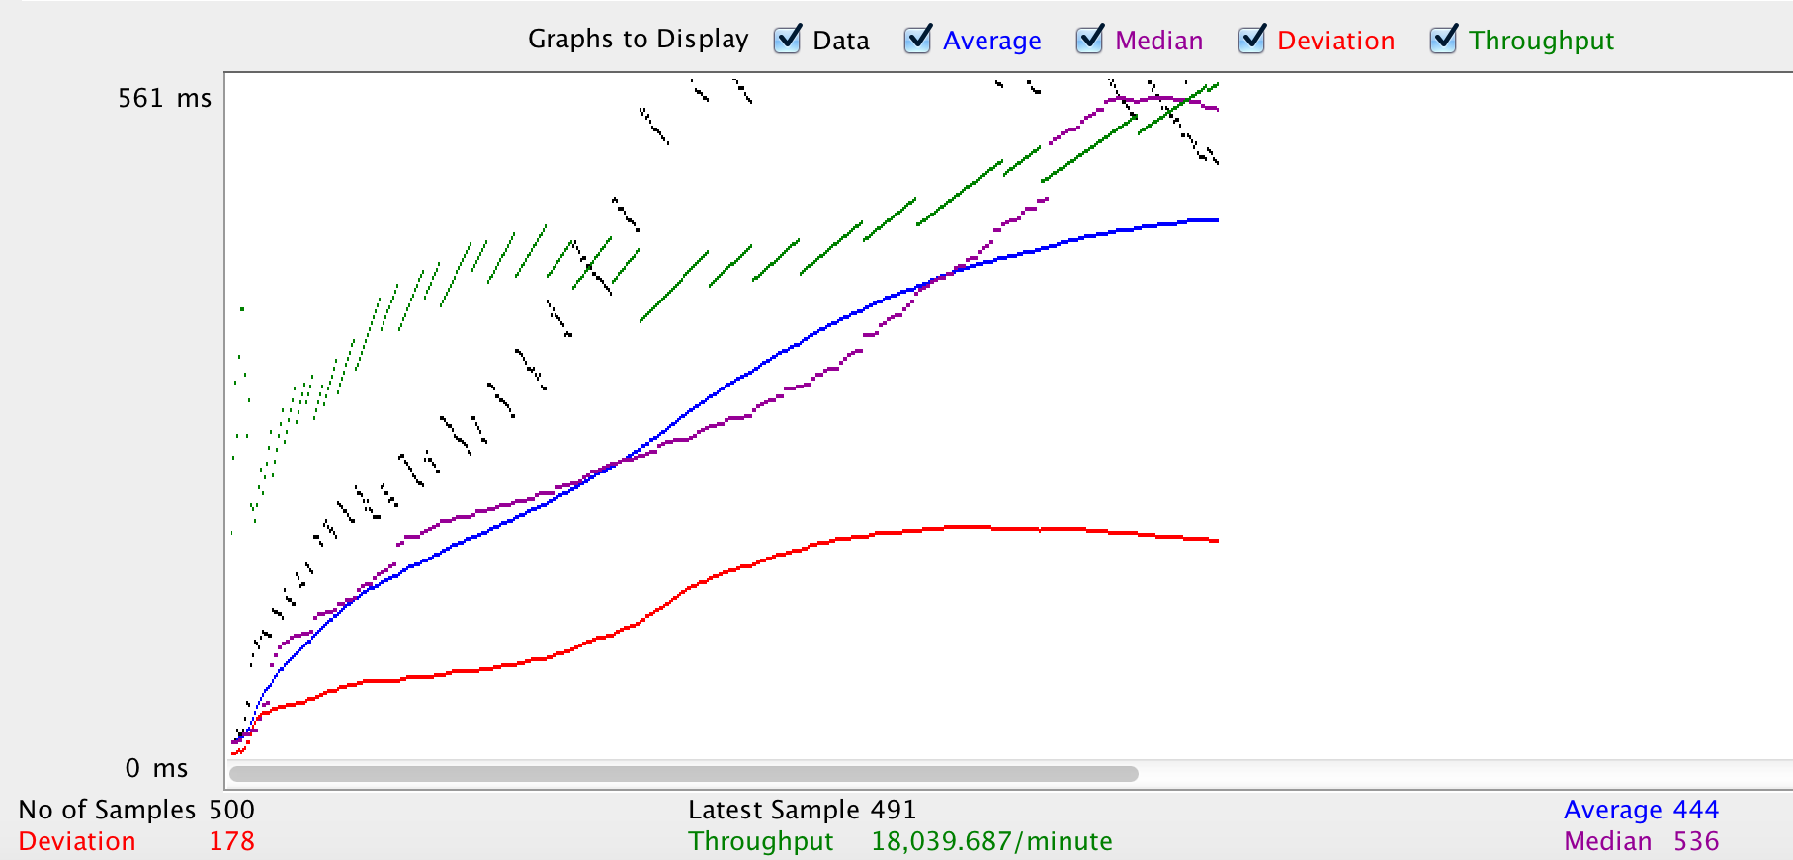500 calls without CP

**Questions:**

1. **Describe your algorithm and strategy for data caching. Discuss why you choose the algorithm/strategy.**

For data caching, Least Recently Used (LRU) algorithm is best suited for this application. LRU maintains the most recently viewed pages in cache and replaces new cache data with the least recently used data.

A user in this application wants to keep himself updated about what his friends are doing at this time of the day. So he is most likely to access only the recent activities happening in his network, like view his friend’s latest posts or view new friend’s profile or a new group he has joined. He tends to re-visit these pages while it is fresh and then forget about it. He is less likely to be interested in activities which are less recent. Also, the user will access his homepage and profile page every-time he uses the application. Hence, these too get added in the most recently visited pages.

1. **Compare the performance characteristics (draw graphs) of the servers without connection pooling and with connection pooling. Repeat the same with data caching. Use a graph or table to chart your results visually. Explain why you see such results.**

Comparison between performance with and without connection pooling is discussed above.

On implementing data caching, retrieving certain pages will be extremely fast as they would be locally available in cache. Number of database calls will reduce and hence performance will be better than both cases mentioned above.

Hence, performance for the same server request call with data caching would have results similar to those mentioned below:

|  |  |  |  |  |  |
| --- | --- | --- | --- | --- | --- |
| **Throughput** | 100 | 200 | 300 | 400 | 500 |
| **With connection pooling** | 98.8/sec | 194.6/sec | 273.0/sec | 351.8/sec | 397.5/sec |
| **Without Connection Pooling** | 97.7/sec | 184.4/sec | 256.0/sec | 285.2/sec | 300.7/sec |
| **With Data Caching** | 99.1/sec | 193.3/sec | 280.7/sec | 354.9/sec | 440.2/sec |

(Object values very locally saved to replicate Data Caching scenario)

1. **Considering data caching, how you would implement Request Caching strategy. Explaining detail. You do not need to implement this new function – pseudo code or a detailed description will be fine.**

Request Caching could be implemented using HTTP etags (entity tag). Etags are random token that label the current state of a data/resource. When data is updated, etag corresponding to that data is also updated at the server. They act as a validation token to check, at a later stage, if the data/resource corresponding to the etag has been modified at the server or not. If the data is not changed, the etags will match and hence, making a server call is not needed as the required data is present in the cache.

When a server responds to client request, it adds etag data in the HTTP header along with other details.

Pseudo code:

At client:

*If client has eTag for data*

*Client sends Etag token in “If-None-Match” HTTP Header*

*If response from server is 304 Not Modified*

*Then use data from cache*

*Else Server returns 200 OK with modified eTag and data*

*Else get data from server and save eTag*

At Server:

*Check client eTag with current eTag*

*If same*

*send 304 Not Modified*

*Else*

*Send modified data and eTag with 200 OK response*

Request caching can also be improved by caching certain javascript pages and Stylesheets. These pages are mostly consistent throughout the application and are loaded on every page call. We can reduce these roundtrips on every page load by saving them locally.

1. **Is your session strategy horizontally scalable? If YES, explain your session handling strategy. If NO, then explain how can you achieve it.**

In the current application, client session strategy is implemented where user data is stored in cookies. This strategy is not horizontally scalable. In order to have a horizontally scalable session strategy, server session strategy need to be implemented.

Server session can be maintained in the database, rather than the browser. This session data will be replicated/available across every database node. Hence, if the first request was routed to one node and the next request from the same source to another database node/replica, its session details can be retrieved from the database entry and there is no conflict in session state among the database nodes.

1. **Explain how node.js handles multiple client requests simultaneously even though it is single threaded. Explain using block diagram.**

Node creates events for every I/O driven operation, which are usually the operations that consume the most time. These events have a call-back function attached to it which gets called once the event operation is over. Thus, the main thread in node is not blocked doing some time-consuming activity. Every activity is done separately in the form of events.

In case of multiple client requests simultaneously, each request is executed in the form of a queue and all the time consuming activities are separated into events functions. Hence, all requests get processed very quick with I/O activities being forked from the main thread, and the responses are returned when through the call-back function.

Callback

Response

Multiple HTTP Requests

Blocking I/O operations forked

Operation completed

Intensive Operations

Event Loop

(Single Thread)